**CHAPTER 1**

**INTRODUCTION TO VLSI & VERILOG HDL**

**1.1 Introduction to VLSI**

Very large-scale integration (VLSI) is the process of integrating or embedding hundreds of thousands of transistors on a single silicon semiconductor microchip. VLSI technology was conceived in the late 1970s when advanced level computer processor microchips were under development. The [microprocessor](http://en.wikipedia.org/wiki/Microprocessor) is a VLSI device. Before the introduction of VLSI technology, most ICs had a limited set of functions they could perform. An [electronic circuit](http://en.wikipedia.org/wiki/Electronic_circuit) might consist of a [CPU](http://en.wikipedia.org/wiki/Central_processing_unit), [ROM](http://en.wikipedia.org/wiki/Read-only_memory), [RAM](http://en.wikipedia.org/wiki/Random_Access_Memory) and other [glue logic](http://en.wikipedia.org/wiki/Glue_logic). VLSI lets IC designers add all of these into one chip.

Microprocessors are essential to many of the products we use every day such as TVs, cars, radios, home appliances and of course, computers. Transistors are the main components of microprocessors. At their most basic level, transistors may seem simple. But their development actually required many years of painstaking research. Before transistors, computers relied on slow, inefficient vacuum tubes and mechanical switches to process information. In 1958, engineers managed to put two transistors onto a Silicon crystal and create the first integrated circuit, which subsequently led to the first microprocessor.

Invention of transistor was the driving factor of growth in the VLSI Technology. Before we get to know about the VLSI Technology, let us have a basic knowledge of [Electronics](http://www.techulator.com/articles/Electronics.aspx) evolution. Electronics deals with Circuits which involve various active and passive components. These circuits are used in various electronic devices and are called electronic circuits. Originally the components used in electronic circuits like diode were made up of vacuum tubes and were called discrete components. Later when the [Solid State Device (SSD)](http://www.techulator.com/articles/SSD.aspx) was invented, the components were made up of semiconductors. Vacuum tubes had the disadvantage of its size, power requirement and reliability.

**1.1.1 History of VLSI**

During the mid-1920s, several inventors attempted devices that were intended to control current in solid-state diodes and convert them into triodes. Success had to wait until after World War II (WWII), during which the attempt to improve silicon and germanium crystals for use as radar detectors led to improvements in fabrication and in the understanding of quantum mechanical states of carriers in semiconductors. Then scientists who had been diverted to radar development returned to solid-state device development. With the invention of transistors at Bell Labs in 1947, the field of electronics shifted from vacuum tubes to solid-state devices.

With the small and effect transistor at their hands, electrical engineers of the 1950s saw the possibilities of constructing far more advanced circuits. As the complexity of circuits grew, problems arose.

One problem was the size of the circuit. A complex circuit, like a computer, was dependent on speed. If the components of the computer were too large or the wires interconnecting them too long, the electric signals couldn't travel fast enough through the circuit, thus making the computer too slow to be effective.

[Jack Kilby](http://en.wikipedia.org/wiki/Jack_Kilby) at [Texas Instruments](http://en.wikipedia.org/wiki/Texas_Instruments) found a solution to this problem in 1958. Kilby's idea was to make all the components and the chip out of the same block (monolith) of semiconductor material. Kilby presented his idea to his superiors, and was allowed to build a test version of his circuit. In September 1958, he had his first integrated circuit ready. Although the first integrated circuit was crude and had some problems, the idea was groundbreaking. By making all the parts out of the same block of material and adding the metal needed to connect them as a layer on top of it, there was no need for discrete components. No more wires and components had to be assembled manually. The circuits could be made smaller, and the manufacturing process could be automated. From here, the idea of integrating all components on a single silicon wafer came into existence, which led to development in small-scale integration (SSI) in the early 1960s, medium-scale integration (MSI) in the late 1960s, and then large-scale integration (LSI) as well as VLSI in the 1970s and 1980s, with tens of thousands of transistors on a single chip (later hundreds of thousands, then millions, and now billions (109)).

**1.1.2 Development**

The first semiconductor chips held two transistors each. Subsequent advances added more transistors, and as a consequence, more individual functions or systems were integrated over time. The first integrated circuits held only a few devices, perhaps as many as ten [diodes](http://en.wikipedia.org/wiki/Diode), [transistors](http://en.wikipedia.org/wiki/Transistor), [resistors](http://en.wikipedia.org/wiki/Resistor) and [capacitors](http://en.wikipedia.org/wiki/Capacitor), making it possible to fabricate one or more [logic gates](http://en.wikipedia.org/wiki/Logic_gate) on a single device. Now known as [small-scale integration](http://en.wikipedia.org/wiki/Integrated_circuit#SSI.2C_MSI_and_LSI) (SSI), improvements in this technique led to devices with hundreds of logic gates, known as [medium-scale integration](http://en.wikipedia.org/wiki/Integrated_circuit#SSI.2C_MSI_and_LSI) (MSI). Further improvements led to [large-scale integration](http://en.wikipedia.org/wiki/Integrated_circuit#SSI.2C_MSI_and_LSI) (LSI), i.e. systems with at least a thousand logic gates. Current technology has moved far past this mark and today's [microprocessors](http://en.wikipedia.org/wiki/Microprocessor) have many millions of gates and billions of individual transistors.

At one time, there was an effort to name and calibrate various levels of large-scale integration above VLSI. Terms like [ultra-large-scale integration](http://en.wikipedia.org/wiki/Integrated_circuit#ULSI.2C_WSI.2C_SOC_and_3D-IC) (ULSI) were used. But the huge number of gates and transistors available on common devices has rendered such fine distinctions moot. Terms suggesting greater than VLSI levels of integration are no longer in widespread use.

As of early 2008, billion-transistor processors are commercially available. This became more common place as semiconductor fabrication advanced from the then-current generation of [65 nm](http://en.wikipedia.org/wiki/65_nanometer) processes. Current designs, unlike the earliest devices, use extensive [design automation](http://en.wikipedia.org/wiki/Electronic_Design_Automation) and automated [logic synthesis](http://en.wikipedia.org/wiki/Logic_synthesis) to [lay out](http://en.wikipedia.org/wiki/Integrated_circuit_layout) the transistors, enabling higher levels of complexity in the resulting logic functionality. Certain high-performance logic blocks like the SRAM ([static random-access memory](http://en.wikipedia.org/wiki/Static_random-access_memory)) cell, are still designed by hand to ensure the highest efficiency. VLSI technology may be moving toward further radical miniaturization with introduction of [NEMS](http://en.wikipedia.org/wiki/Nanoelectromechanical_systems) technology.

**1.1.3 ASIC**

An application-specific integrated circuit (ASIC) is an [integrated circuit](http://en.wikipedia.org/wiki/Integrated_circuit)(IC) customized for a particular use, rather than intended for general-purpose use. For example, a chip designed to run in a [digital voice recorder](http://en.wikipedia.org/wiki/Digital_voice_recorder) or a high-efficiency [Bit coin miner](http://en.wikipedia.org/wiki/Bitcoin_mining#Bitcoin_mining) is an ASIC. [Application-specific standard products](http://en.wikipedia.org/wiki/Application-specific_standard_product) (ASSPs) are intermediates between ASICs and industry standard integrated circuits like the [7400](http://en.wikipedia.org/wiki/7400_series)or the [4000 series](http://en.wikipedia.org/wiki/4000_series).

As feature sizes have shrunk and design tools improved over the years, the maximum complexity (and hence functionality) possible in an ASIC has grown from 5,000 [gates](http://en.wikipedia.org/wiki/Logic_gate) to over 100 million. Modern ASICs often include entire [microprocessors](http://en.wikipedia.org/wiki/Central_processing_unit), [memory](http://en.wikipedia.org/wiki/Memory) blocks including [ROM](http://en.wikipedia.org/wiki/Read-only_memory), [RAM](http://en.wikipedia.org/wiki/RAM), [EEPROM](http://en.wikipedia.org/wiki/EEPROM), [flash memory](http://en.wikipedia.org/wiki/Flash_memory) and other large building blocks. Such an ASIC is often termed a SoC ([system-on-chip](http://en.wikipedia.org/wiki/System-on-chip)). Designers of digital ASICs often use a [hardware description language](http://en.wikipedia.org/wiki/Hardware_description_language) (HDL), such as [Verilog](http://en.wikipedia.org/wiki/Verilog) or [VHDL](http://en.wikipedia.org/wiki/VHDL), to describe the functionality of ASICs.

[Field-programmable gate arrays](http://en.wikipedia.org/wiki/Field-programmable_gate_array) (FPGA) are the modern-day technology for building a [breadboard](http://en.wikipedia.org/wiki/Breadboard) or prototype from standard parts; programmable logic blocks and programmable interconnects allow the same FPGA to be used in many different applications. For smaller designs or lower production volumes, FPGAs may be more cost effective than an ASIC design even in production. The [non-recurring engineering](http://en.wikipedia.org/wiki/Non-recurring_engineering) (NRE) cost of an ASIC can run into the millions of dollars.

**1.1.4 VLSI Classification**

VLSI is a successor to large-scale integration (LSI), medium-scale integration (MSI) and small-scale integration (SSI) technologies. The first 1 mega byte RAM was built on top of VLSI design principles and included more than one million transistors on its microchip dye. Depending upon the number of components (transistors) to be integrated, they were categorized as SSI, MSI, LSI, VLSI, ULSI & GSI.

**Small Scale Integration (SSI)**   
In this technology, 1-100 transistors were fabricated on a single chip. E.g.: Gates, Flip-flops.  
**Medium Scale Integration (MSI)**   
Using this technology, 100-1000 number of transistors could be integrated on a single chip. E.g.: 4 bit Microprocessors.  
**Large Scale Integration** (**LSI)**   
In this technology, 1000-10000 transistors could be integrated on a single chip. E.g.8 bit Microprocessors, RAM, ROM.

**Very Large Scale Integration (VLSI)**  
In this technology, 10000-1 million transistors could be accommodated. E.g:16-32 bit Microprocessors.  
**Ultra Large Scale Integration (ULSI)**  
In this technology, 1 million-10 million transistors could be accommodated. Eg: Special Purpose Registers.  
**Giant Scale Integration (GSI)**   
In this technology, more than 10 million transistors could be accommodated. Eg: Embedded Systems.

**1.1.5 Advantages and Applications of VLSI**

**1.1.5.1 Advantages of VLSI**

VLSI has many advantages. Some of them are:   
1. It reduces the size of circuits.  
2. It reduces the effective cost of the devices.  
3. It increases the operating speed of circuits  
4. It requires less power than discrete components.  
5. It higher reliability  
6. It occupies a relatively smaller area.

**1.1.5.2 Applications of VLSI**

In today's world, VLSI chips are widely used in various branches of engineering like:   
1. Voice and Data Communication networks  
2. Digital Signal Processing  
3. [Computers](http://www.techulator.com/articles/Computer-Hardwares.aspx)  
4. Commercial Electronics  
5. [Automobiles](http://www.techulator.com/articles/Automobiles.aspx)  
6. Medicine and many more.

**1.2 Introduction to Verilog HDL**

Verilog, standardized as IEEE 1364, is a [hardware description language](http://en.wikipedia.org/wiki/Hardware_description_language) (HDL) used to model electronic systems. It is most commonly used in the design and verification of [digital circuits](http://en.wikipedia.org/wiki/Digital_electronics) at the [register-transfer level](http://en.wikipedia.org/wiki/Register-transfer_level) of [abstraction](http://en.wikipedia.org/wiki/Abstraction_(computer_science)). It is also used in the verification of [analog circuits](http://en.wikipedia.org/wiki/Analogue_electronics) and [mixed-signal circuits](http://en.wikipedia.org/wiki/Mixed-signal_integrated_circuit).

A Verilog design consists of a hierarchy of modules. Modules encapsulate design hierarchy, and communicate with other modules through a set of declared input, output, and bidirectional ports. Internally, a module can contain any combination of the following: net/variable declarations (wire, reg, integer, etc.), concurrent and sequential statement blocks, and instances of other modules (sub-hierarchies). Sequential statements are placed inside a begin/end block and executed in sequential order within the block. However, the blocks themselves are executed concurrently, making Verilog a [dataflow language](http://en.wikipedia.org/wiki/Dataflow_language).

Verilog's concept of 'wire' consists of both signal values (4-state: "1, 0, floating, undefined") and signal strengths (strong, weak, etc.). This system allows abstract modeling of shared signal lines, where multiple sources drive a common net. When a wire has multiple drivers, the wire's (readable) value is resolved by a function of the source drivers and their strengths.

A subset of statements in the Verilog language is [synthesizable](http://en.wikipedia.org/wiki/Logic_synthesis). Verilog modules that conform to a synthesizable coding style, known as RTL (register-transfer level); can be physically realized by synthesis software. Synthesis software algorithmically transforms the (abstract) Verilog source into a [netlist](http://en.wikipedia.org/wiki/Netlist), a logically equivalent description consisting only of elementary logic primitives (AND, OR, NOT, flip-flops, etc.) that are available in a specific [FPGA](http://en.wikipedia.org/wiki/FPGA) or [VLSI](http://en.wikipedia.org/wiki/VLSI) technology. Further manipulations to the netlist ultimately lead to a circuit fabrication blueprint (such as a [photo mask set](http://en.wikipedia.org/wiki/Mask_set) for an [ASIC](http://en.wikipedia.org/w/index.php?title=Application-specific_integrated&action=edit&redlink=1) or a [bitstream](http://en.wikipedia.org/wiki/Bitstream) file for an [FPGA](http://en.wikipedia.org/wiki/FPGA)).

**1.2.1 History**

Verilog was one of the first modern hardware description languages to be invented. It was created by [Prabhu Goel](http://en.wikipedia.org/wiki/Prabhu_Goel) and [Phil Moorby](http://en.wikipedia.org/wiki/Phil_Moorby) during the winter of 1983/1984. The wording for this process was "Automated Integrated Design Systems" (later renamed to [Gateway Design Automation](http://en.wikipedia.org/wiki/Gateway_Design_Automation) in 1985) as a hardware modeling language. Gateway Design Automation was purchased by [Cadence Design Systems](http://en.wikipedia.org/wiki/Cadence_Design_Systems) in 1990. Cadence now has full proprietary rights to Gateway's Verilog and the Verilog-XL, the HDL-simulator that would become the de facto standard (of Verilog [logic simulators](http://en.wikipedia.org/wiki/Logic_simulator)) for the next decade. Originally, Verilog was intended to describe and allow simulation; only afterwards was support for synthesis added.

Verilog is a portmanteau of the words "verification" and "logic".

**1.2.2 Versions**

**1.2.2.1 Verilog 95**

With the increasing success of [VHDL](http://en.wikipedia.org/wiki/VHDL) at the time, Cadence decided to make the language available for open [standardization](http://en.wikipedia.org/wiki/Standardization). Cadence transferred Verilog into the public domain under the [Open Verilog International](http://www.ovi.org/) (OVI) (now known as [Accellera](http://en.wikipedia.org/wiki/Accellera)) organization. Verilog was later submitted to [IEEE](http://en.wikipedia.org/wiki/IEEE) and became IEEE Standard 1364-1995, commonly referred to as Verilog-95.

In the same time frame Cadence initiated the creation of [Verilog-A](http://en.wikipedia.org/wiki/Verilog-A) to put standards support behind its analog simulator [Spectre](http://en.wikipedia.org/wiki/Spectre_Circuit_Simulator). Verilog-A was never intended to be a standalone language and is a subset of [Verilog-AMS](http://en.wikipedia.org/wiki/Verilog-AMS) which encompassed Verilog-95.

### 1.2.2.2 Verilog 2001

Extensions to Verilog-95 were submitted back to IEEE to cover the deficiencies that users had found in the original Verilog standard. These extensions became [IEEE](http://en.wikipedia.org/wiki/IEEE) Standard 1364-2001 known as Verilog-2001.

Verilog-2001 is a significant upgrade from Verilog-95. First, it adds explicit support for (2's complement) signed nets and variables. Previously, code authors had to perform signed operations using awkward bit-level manipulations (for example, the carry-out bit of a simple 8-bit addition required an explicit description of the Boolean algebra to determine its correct value). The same function under Verilog-2001 can be more succinctly described by one of the built-in operators: +, -, /, *, >>>. A generate/end generate construct (similar to VHDL's generate/end generate) allows Verilog-2001 to control instance and statement instantiation through normal decision operators (case/if/else). Using generate/end generate, Verilog-2001 can instantiate an array of instances, with control over the connectivity of the individual instances. File I/O has been improved by several new system tasks. And finally, a few syntax additions were introduced to improve code readability (e.g. always, @*, named parameter override, C-style function/task/module header declaration).

### 1.2.2.3 Verilog 2005

Not to be confused with [SystemVerilog](http://en.wikipedia.org/wiki/SystemVerilog), Verilog 2005 ([IEEE](http://en.wikipedia.org/wiki/IEEE) Standard 1364-2005) consists of minor corrections, spec clarifications, and a few new language features (such as the uwire keyword).

A separate part of the Verilog standard, [Verilog-AMS](http://en.wikipedia.org/wiki/Verilog-AMS), attempts to integrate analog and mixed signal modeling with traditional Verilog.

### 1.2.2.4 SystemVerilog

SystemVerilog is a [superset](http://en.wikipedia.org/wiki/Superset) of Verilog-2005, with many new features and capabilities to aid design verification and design modeling. As of 2009, the SystemVerilog and Verilog language standards were merged into SystemVerilog 2009 (IEEE Standard 1800-2009).

**1.3 Organization of the Report**

This report starts with an overview of the transmitting and receiving data without any data loss using an interface called FIFO. We analyze the impact of transferring data at different clock domains to increase the speed of the FIFO; this design uses combined binary/Gray counters that take advantage of the built-in binary ripple carry logic. The report is organized as follows:

Chapter 1: Introduction to VLSI & Verilog HDL- This chapter briefly explains the overview of VLSI and Verilog HDL.

Chapter 2: Software & Hardware Tool - This chapter describes about the tools that are used in this project to write, simulate the code and process for dumping the code into FPGA board.

Chapter 3: Literature Survey - This chapter describes about the survey done on this project and its usage for designing the Asynchronous FIFO

Chapter 4: Asynchronous FIFO Design –This chapter describes about the design and block diagram of asynchronous FIFO.

Chapter 5: Description of the Modules - This chapter explains about the different modules that are present in the project to transfer the data without any data loss

Chapter 6: Result- This chapter shows all the waveforms that are obtained after the execution of the code in Xilinx and outputs of the code after dumping into FPGA board.

Chapter 7: Conclusions - This chapter summarizes the major accomplishments of this report.

**CHAPTER 2**

**SOFTWARE & HARDWARE TOOLS**

**2.1 Software Tool-Xilinx**

Xilinx ISE is a software tool produced by Xilinx for synthesis and analysis of HDL designs, which enables the developer to synthesize ("compile") their designs, perform timing analysis, examine RTL diagrams, simulate a design's reaction to different stimuli, and configure the target device with the programmer.Xilinx was founded in 1984 by two semiconductor [engineers](http://en.wikipedia.org/wiki/Engineers), [Ross Freeman](http://en.wikipedia.org/wiki/Ross_Freeman) and [Bernard Vonder Schmitt](http://en.wikipedia.org/wiki/Bernard_Vonderschmitt), who were both working for [integrated circuit](http://en.wikipedia.org/wiki/Integrated_circuit) and solid-state device manufacturer [Zilog](http://en.wikipedia.org/wiki/Zilog) Corp.

While working for Zilog, Freeman wanted to create chips that acted like a blank tape, allowing users to program the technology themselves. At the time, the concept was [paradigm](http://en.wikipedia.org/wiki/Paradigm)-changing. "The concept required lots of [transistors](http://en.wikipedia.org/wiki/Transistors) and, at that time, transistors were considered extremely precious – people thought that Ross's idea was pretty far out", said Xilinx Fellow Bill Carter, who when hired in 1984 as the first IC designer was the company's eighth employee. Xilinx is a software tool, which is used to run the programs in VHDL language. It has various versions like Xilinx 9.2I, Xilinx 10.1, Xilinx 10.5 and Xilinx 14.5 etc. Xilinx has various pre-defined libraries, packages.

**2.1.1 Version 14.5I**

## New Device Support

## This release supports the new Spartan™- 3A DSP family.

## New Software Features

## Following are the new features in this release.

## Operating System Support:

* Support for Windows® Vista Business 32-bit operating system.
* This operating system is supported, but has had limited testing.
* Support for Windows XP Professional 64-bit operating system
* Support for Red Hat Enterprise WS 5.0 32-bit and 64-bit operating system. This operating system is supported, but has had limited testing.

WHY XILINX ONLY?

We have many software tools to run the Verilog programs like cadence .But compared to all software tools Xilinx is cost effective.

**2.2 Tutorial of ISE 14.5I**

**2.2.1 ISE 14.5i Quick Start Tutorial**

The ISE 14.5i Quick Start Tutorial provides Xilinx PLD designers with a quick overview of the basic design process using ISE 14.5i. After you have completed the tutorial, you will have an understanding of how to create, verify, and implement a design.

**Note:** This tutorial is designed for ISE 14.5i on Windows.

This tutorial contains the following sections:

* “Getting Started”
* “Create a New Project”
* “Create an HDL Source”
* “Design Simulation”
* “Create Timing Constraints”
* “Implement Design and Verify Constraints”
* “Re-implement Design and Verify Pin Locations”
* “Download Design to the Spartan™-3 Demo Board”

For an in-depth explanation of the ISE design tools, see the ISE In-Depth Tutorial on the Xilinx® web site at: http://www.xilinx.com/support/techsup/tutorials/

*Getting Started*

**Software Requirements:**

To use this tutorial, you must install the following software:

* ISE 14.5I

For more information about installing Xilinx® software, see the ISE Release Notes and

Installation Guide at: http://www.xilinx.com/support/software_manuals.htm.

**Hardware Requirements:**

To use this tutorial, you must have the following hardware:

* Spartan-3E Startup Kit, containing the Spartan-3E Startup Kit Demo Board

*Starting the ISE Software.* To start ISE, double-click the desktop icon,

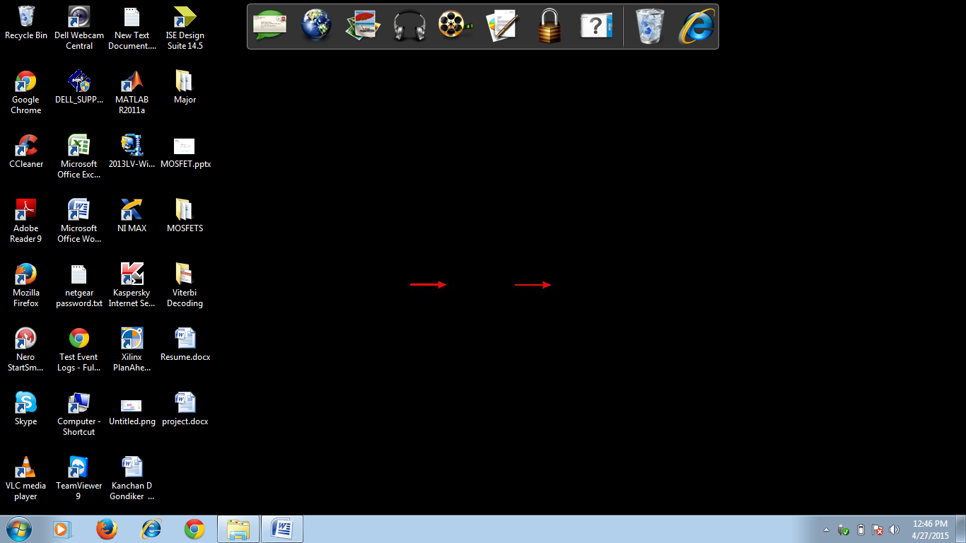

Or start ISE from the Start menu by selecting:

*Start → All Programs → Xilinx ISE 14.5i → Project Navigator*

**Note:** Your start-up path is set during the installation process and may differ from the one above.

*Accessing Help*

At any time during the tutorial, you can access online help for additional information. About the ISE software and related tools.

To open Help, do either of the following:

* Press **F1** to view Help for the specific tool or function that you have selected or highlighted.
* Launch the **ISE Help Contents** from the Help menu. It contains information about Creating and maintaining your complete design flow in ISE.

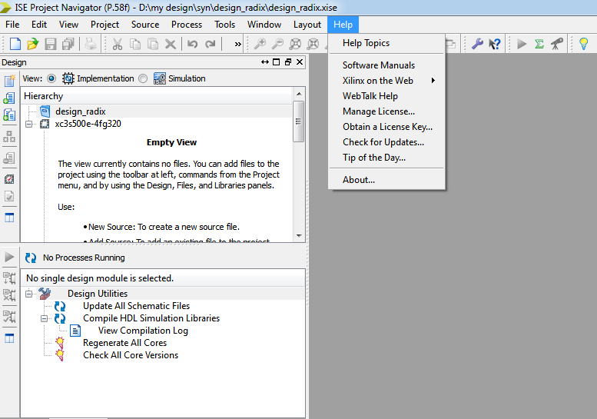

**Figure 2.1** ISE Help Topics

*Create a New Project*

Create a new ISE project which will target the FPGA device on the Spartan-3 Startup Kit demo board.

To create a new project:

1. Select **File** >**New Project...** The New Project Wizard appears.

2. Type **tutorial** in the Project Name field.

3. Enter or browse to a location (directory path) for the new project. A tutorial subdirectory is created automatically.

4. Verify that **HDL** is selected from the Top-Level Source Type list.

5. Click **Next** to move to the device properties page.

6. Fill in the properties in the table as shown below:

* Product Category: **All**
* Family: **Spartan3E**
* Device: **XC3S500E**
* Package: **FG320**
* Speed Grade: **-4**
* Top-Level Module Type: **HDL**
* Synthesis Tool: **XST (VHDL/Verilog)**
* Simulator: **ISE Simulator (VHDL/Verilog)**
* Verify that **Enable Enhanced Design Summary** is selected.

Leave the default values in the remaining fields.

When the table is complete, your project properties will look like the following:

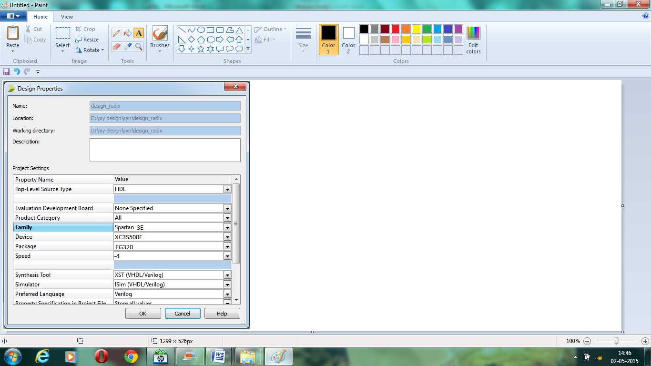

**Figure 2.2** Project Device Properties

7. Click **next** to proceed to the Create New Source window in the New Project Wizard. At the end of the next section, your new project will be complete.

*Create a Verilog HDL Source*

In this section, I will create an example top-level Verilog HDL file

*Creating a Verilog Source*

Create the top-level Verilog source file as follows:

1. Click **New Source** in the New Project dialog box.

2. Select **Verilog Module** as the source type in the New Source dialog box.

3. Type in the file name **counter**.

4. Verify that the **Add to Project** checkbox is selected.

5. Click **Next**.

6.Declare the ports for the counter design by filling in the port information as show Below: 

**Figure 2.3** Define Module

7. Click **next**, and then **Finish** in the New Source Information dialog box to complete the new source file template.

8. Click **Next**, then **Next**, then **Finish**.

The source file containing the counter module displays in the Workspace, and the counter displays in the Sources tab, as shown below:



**Figure 2.4** New Project in ISE

*Using Language Templates (Verilog)*

The next step in creating the new source is to add the behavioral description for counter.

Use a simple counter code example from the ISE Language Templates and customize it for the counter design.

1. Place the cursor on the line below the output [3:0] COUNT_OUT; statement.

2. Open the Language Templates by selecting **Edit** → **Language Templates…**

**Note:** You can tile the Language Templates and the counter file by selecting **Window** → **Tile Vertically** to make them both visible.

3. Using the “**+**” symbol, browse to the following code example:

Verilog → Synthesis Constructs → Coding Examples → Counter → Binary →

Up/Down Counters → Simple Counter

4. With Simple Counter selected, select **Edit** → **Use in File**, or select the **Use Template in File** toolbar button. This step copies the template into the counter source file.

5. Close the Language Templates.

*Final Editing of the Verilog Source*

1. To declare and initialize the register that stores the counter value, modify the

Declaration statement in the first line of the template as follows:

Replace: reg [<upper>:0] <reg_name>;

with: reg [3:0] count_int = 0;

2. Customize the template for the counter design by replacing the port and signal name

Placeholders with the actual ones as follows:

* replace all occurrences of <clock> with CLOCK
* replace all occurrences of <up_down> with DIRECTION
* replace all occurrences of <reg_name> with count_int

3. Add the following line just above the endmodule statement to assign the register value to the output port:

assign COUNT_OUT = count_int;

4. Save the file by selecting **File** → **Save**.

When you are finished, the code for the counter will look like the following:

module counter(CLOCK, DIRECTION, COUNT_OUT);

input CLOCK;

input DIRECTION;

output [3:0] COUNT_OUT;

reg [3:0] count_int = 0;

always @(posedge CLOCK)

if (DIRECTION)

count_int<= count_int + 1;

else

count_int<= count_int - 1;

assign COUNT_OUT = count_int;

endmodule

You have now created the Verilog source for the tutorial project.

*Checking the Syntax of the New Counter Module*

When the source files are complete, check the syntax of the design to find errors and types.

1. Verify that **Synthesis/Implementation** is selected from the drop-down list in the Sources window.

2. Select the **counter** design source in the Sources window to display the related processes in the Processes window.

3. Click the “**+”** next to the Synthesize-XST process to expand the process group.

4. Double-click the **Check Syntax** process.

**Note:** You must correct any errors found in your source files. You can check for errors in the Console tab of the Transcript window. If you continue without valid syntax, you will not be able to simulate or synthesize your design.

5. Close the HDL file.

**2.2.2 Design Simulation**

*Verifying Functionality using Behavioral Simulation*

Create a test bench waveform containing input stimulus you can use to verify the functionality of the counter module. The test bench waveform is a graphical view of a test bench.

Create the test bench waveform as follows:

1. Select the **counter** HDL file in the Sources window.

2. Create a new test bench source by selecting **Project** → **New Source**.

3. In the New Source Wizard, select **Test Bench Waveform**s the source type, and type **counter_tbw**in the File Name field.

4. Click **Next**.

5. The Associated Source page shows that you are associating the test bench waveform with the source file counter. Click **Next**.

6. The Summary page shows that the source will be added to the project, and it displays the source directory, type and name. Click **Finish**.

7. You need to set the clock frequency, setup time and output delay times in the Initialize Timing dialog box before the test bench waveform editing window opens.

The requirements for this design are the following:

* The counter must operate correctly with an input clock frequency = 25MHz.
* The DIRECTION input will be valid 10 ns before the rising edge of CLOCK.
* The output (COUNT_OUT) must be valid 10 ns after the rising edge of CLOCK.

The design requirements correspond with the values below.

Fill in the fields in the Initialize Timing dialog box with the following information:

* Clock Time High: **20** ns.
* Clock Time Low: **20** ns.
* Input Setup Time: **10** ns.
* Output Valid Delay: **10** ns.
* Offset: **0** ns.
* Global Signals: **GSR (FPGA)**

**Note:** When GSR (FPGA) is enabled, 100 ns. is added to the Offset value automatically.

* Initial Length of Test Bench: **1500** ns.

Leave the default values in the remaining fields.



**Figure 2.5** Initialize Timing

8. Click **Finish** to complete the timing initialization.

9. The blue shaded areas that precede the rising edge of the CLOCK correspond to the Input Setup Time in the Initialize Timing dialog box. Toggle the DIRECTION port to define the input stimulus for the counter design as follows:

* Click on the blue cell at approximately the **300** ns to assert DIRECTION high so that the counter will count up.
* Click on the blue cell at approximately the **900** ns to assert DIRECTION high so that the counter will count down.

**Note:** For more accurate alignment, you can use the **Zoom In** and **Zoom Out** toolbar buttons.



**Figure 2.6** Test Bench Waveform

10. Save the waveform.

11. In the Sources window, select the **Behavioral Simulation** view to see that the test bench waveform file is automatically added to your project.

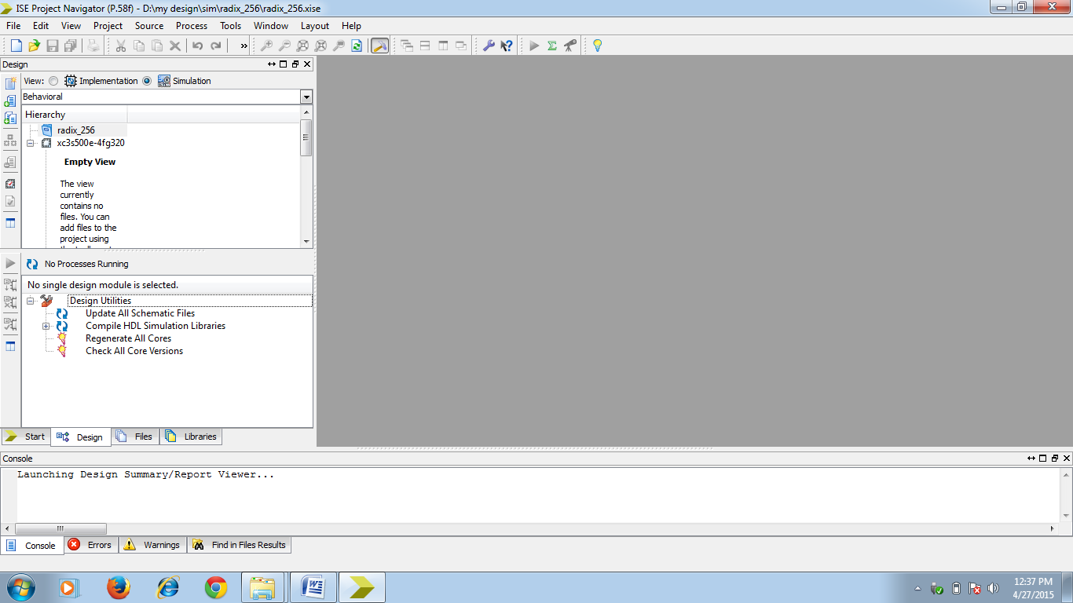

**Figure 2.7** Behavior Simulation Selection

12. Close the test bench waveform.

**2.2.3 Create a Self-Checking Test Bench Waveform**

Add the expected output values to finish creating the test bench waveform. This transforms the test bench waveform into a self-checking test bench waveform. The key benefit to a self-checking test bench waveform is that it compares the desired and actual output values and flags errors in your design as it goes through the various transformations, from behavioral HDL to the device specific representation.

To create a self-checking test bench, edit output values manually, or run the Generate Expected Results process to create them automatically. If you run the Generate Expected Results process, visually inspect the output values to see if they are the ones you expected for the given set of input values.

To create the self-checking test bench waveform automatically, do the following:

1. Verify that **Behavioral Simulation** is selected from the drop-down list in the Sources window.

2. Select the **counter_tbw** file in the Sources window.

3. In the Processes tab, click the “**+**” to expand the Xilinx ISE Simulator process and double-click the **Generate Expected Simulation Results** process. This process simulates the design in a background process.

4. The **Expected Results** dialog box opens. Select **Yes** to annotate the results to the test bench.



**Figure 2.8** Expected Results Dialog Box

5. Click the “**+**” to expand the COUNT_OUT bus and view the transitions that corresponds to the Output Delay value (yellow cells) specified in the Initialize Timing dialog box.



**Figure 2.9** Test Bench Waveform with Results

6. Save the test bench waveform and close it. You have now created a self-checking test bench waveform.

Simulating Design Functionality, Verify that the counter design functions as you expect by performing behavior simulation as follows:

1. Verify that **Behavioral Simulation** and **counter_tbw**are selected in the Sources window.

2. In the **Processes** tab, click the “**+**” to expand the Xilinx ISE Simulator process and double-click the **Simulate Behavioral Model** process. The ISE Simulator opens and runs the simulation to the end of the test bench.

3. To view your simulation results, select the **Simulation** tab and zoom in on the transitions.

The simulation waveform results will look like the following:



**Figure 2.10** Simulation Results

**Note:** You can ignore any rows that start with **TX**.

4. Verify that the counter is counting up and down as expected.

5. Close the simulation view. If you are prompted with the following message, “You have an active simulation open. Are you sure you want to close it? Click **Yes** to continue, you have now completed simulation of your design using the ISE Simulator.

**2.3 Hardware Tools**

A Field-programmable gate array (FPGA) is a semiconductor device that can be configured by the customer or designer after manufacturing—hence the name "field-programmable". FPGAs are programmed using a logic circuit diagram or a source code in a hardware description language (HDL) to specify how the chip will work.

They can be used to implement any logical function that an application-specific integrated circuit (ASIC) could perform, but the ability to update the functionality after shipping offers advantages for many applications. FPGAs contain programmable logic components called "logic blocks", and a hierarchy of reconfigurable interconnects that allow the blocks to be "wired together"—somewhat like a one-chip programmable breadboard.

Logic blocks can be configured to perform complex combinational functions, or merely simple logic gates like AND and XOR. In most FPGAs, the logic blocks also include memory elements, which may be simple flip-flops or more complete blocks of memory.

**2.3.1 History**

The FPGA industry sprouted from programmable read only memory (PROM) and programmable logic devices (PLDs). PROMs and PLDs both had the option of being programmed in batches in a factory or in the field (field programmable), however programmable logic was hard-wired between logic gates. Xilinx Co-Founders, Ross Freeman and Bernard Vonder Schmitt, invented the first commercially viable field programmable gate array in 1985 – the XC2064. The XC2064 had programmable gates and programmable interconnects between gates, the beginnings of a new technology and market. The XC2064 boasted a mere 64 configurable logic blocks (CLBs), with two 3-input lookup tables (LUTs). More than 20 years later, Freeman was entered into the National Inventors Hall of Fame for his invention.

**2.3.2 Architecture**

The most common FPGA architecture consists of an array of configurable logic blocks (CLBs), I/O pads, and routing channels. Generally, all the routing channels have the same width (number of wires). Multiple I/O pads may fit into the height of one row or the width of one column in the array.

An application circuit must be mapped into an FPGA with adequate resources. While the number of CLBs and I/Os required is easily determined from the design, the number of routing tracks needed may vary considerably even among designs with the same amount of logic.

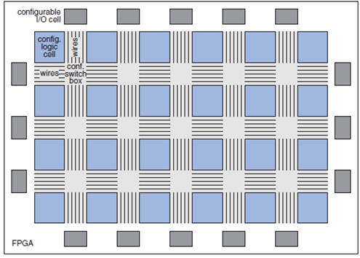

**Figure 2.11** Internal Structure of FPGA

**2.3.3 Applications**

Applications of FPGAs include digital signal processing, software-defined radio, aerospace and defense systems, ASIC prototyping, medical imaging, computer vision, speech recognition, cryptography, bioinformatics, computer hardware emulation, radio astronomy and a growing range of other areas.

**2.4 A Brief Tutorial**

**2.4.1 Source Code is dumped into FPGA.**

1. Now let’s look at the flow for actually synthesizing and implementing the design in the FPGA prototyping boards. Close Model Sim and go back to the Xilinx ISE environment. In the Sources sub window change the selection in the dropdown box from “Behavioral Simulation” to “Synthesis / Implementation”.

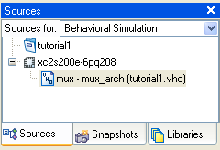 🡪 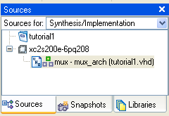

**Figure 2.12** Source code dumping into FPGA

1. To properly synthesize the design we need to specify which pins on the chip all the inputs and outputs should be assigned to. In general of course we could assign the signals just about any way we want. Since we will be using specific prototype boards, we need to make sure our pins assignments match the switches, buttons, and LEDs so we can test our design. We will be starting with Digilab 2E boards that are connected to Digilab DIO2 input/output boards. The I/O board has already been programmed and configured to have the following connections:

**Table 2.1** I/O connections:  
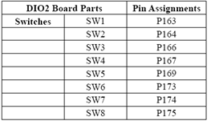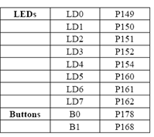

1. To assign specific pins, expand the User Constraints selection under the Process sub window and double-click on Assign Package Pins.

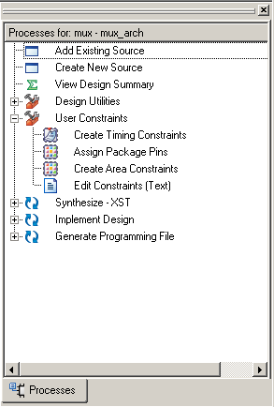

**Figure 2.13 A**ssigning package pins

1. A new application called Xilinx PACE should be launched.

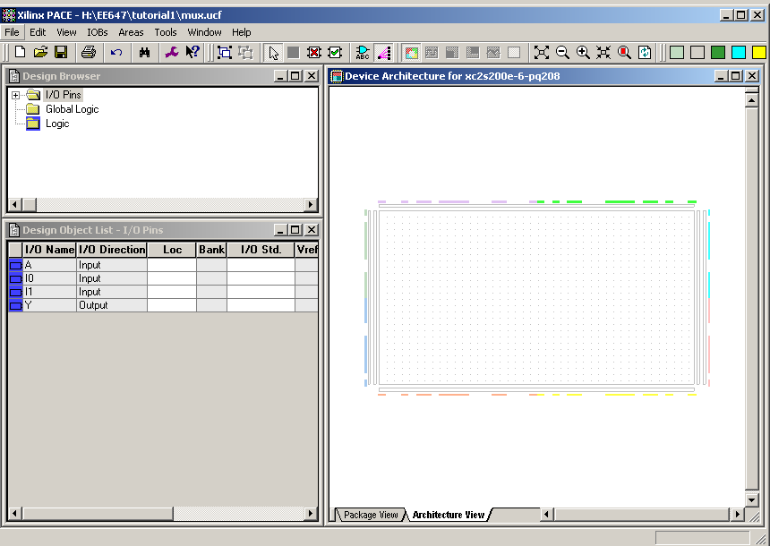  
**Figure 2.14** Launching Xilinx PACE

* 1. In the Design Object List sub window you should see a listing of all the input and output signals from our design.

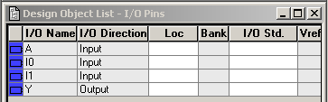

**Figure 2.15** Design object list

Here is where we can specify which pin locations we want for each signal. Simply enter the pins numbers from the tables shown in Step 19 above, making sure to use a capital letter “P” in front of the pin specification. Let’s assign our signals as

A 🡨 P163 (Switch 1)  
 I0 🡨 P164 (Switch 2)  
 I1 🡨 P166 (Switch 3)  
 Y 🡨 P149 (LED 0)

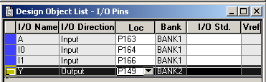

**Figure 2.16** Assigning Design object list to pins

Once all pins have been assigned, save your constraints by selecting File 🡪 Save from the menu bar and exit Xilinx Pace.

1. Back in the Xilinx ISE. In the Process sub window double-click on the Synthesize – XST selection and wait for the process to complete. Then double-click on the Implement Design selection and wait for the process to complete. Then double-click on the Generate Programming File selection and wait for the process to complete. If all goes well, you should have green checks marks for the whole design.

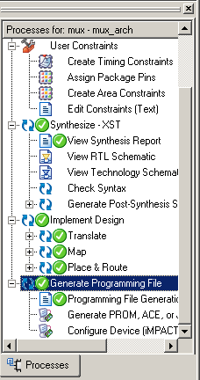

**Figure 2.17** Processes for dumping code into FPGA

1. There is a lot of information you can obtain through all of the objects listed in the Processes sub window, but let us proceed to downloading the design onto the prototyping board for testing. First make sure the prototyping board is connected to the PC and has power on. Also make sure the slide switch on the FPGA board by the parallel port is set to JTAG (as opposed to “Port”). Then select Configure Device (IMPACT) underneath the Generate Programming File selection. You should the following window.

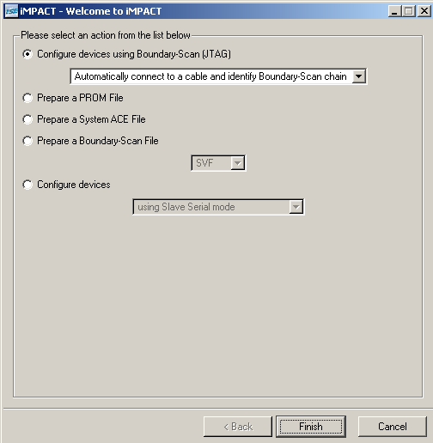

**Figure 2.18** IMPACT in FPGA

1. Now you need to specify which bit stream file to use to configure the device. For this tutorial we want to select the mux.bit file and click Open.

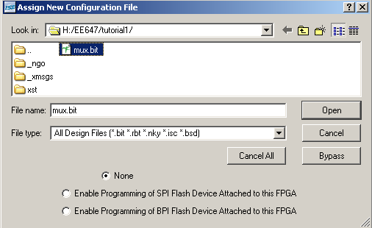

**Figure 2.19** Assigning New configuration File

You will probably get the message below. Just click Yes.

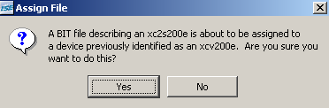  
**Figure 2.20** Assign Bit file

You will also get a warning message saying the JTAG clock was updated in the bit stream file (which is good) so just click OK. There is a way to correct for that in the original design flow, but Xilinx automatically catches it here so I don’t usually bother.

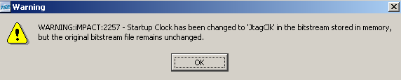

**Figure 2.21** Warning message for JTAG update

1. You should now see the Spartan XC2S200E chip in the main window. Right click on the chip to prepare for downloading the bit stream file.  
   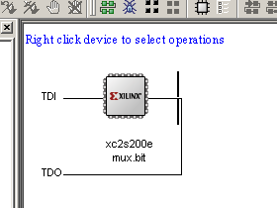

Select Program on the resulting window.

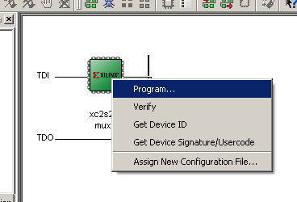

1. Click OK.

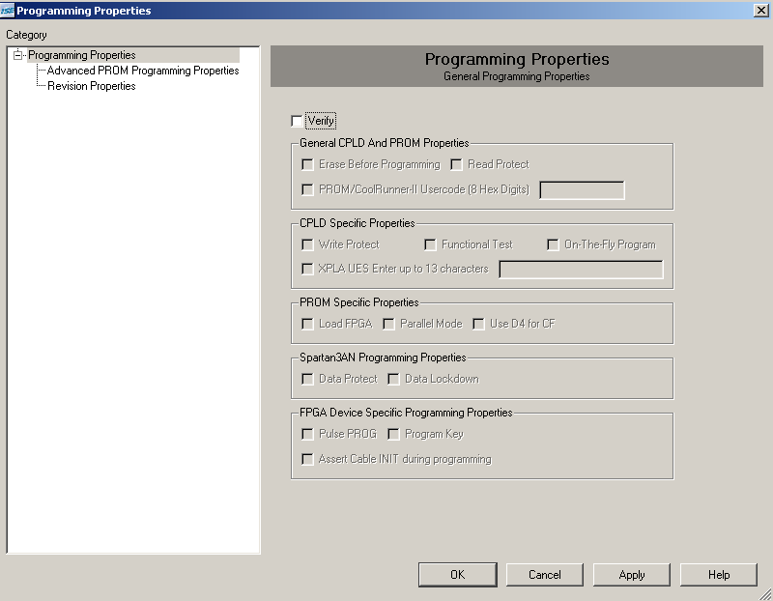  
If all goes well you should get the Programming Succeeded message  
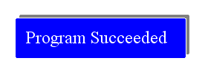

1. Now just test and verify your design on the actual FPGA board!

**2.4.2 Programming Platform Flash PROM via USB**

The on-board USB-JTAG circuitry also programs the Xilinx XCF04S serial Platform Flash PROM. The following steps mentioned below describe how to set up the PROM file and howto download it to the board to ultimately program the FPGA. Generating the FPGA Configuration Bit stream File

1. Generating the PROM File:After generating the program file, double-click Generate PROM, ACE, or JTAG Fileto launch the iMPACT software, as shown in

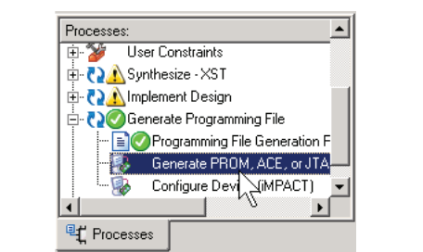

**Figure 2.22** Double-Click Generate PROM, ACE, or JTAG File

1. A new window ISE iMPACT appears on the screen. Now click on boundary scan and initialize chain. Choose Xilinx PROM as target PROM type, as shown in

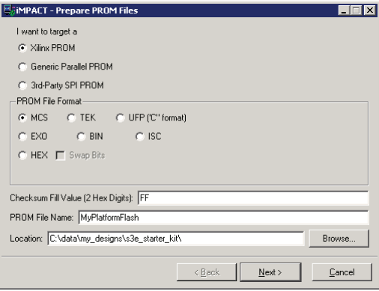

**Figure 2.23** Choose the PROM Target Type, the, Data Format, and File Location

Select from any of the PROM File Formats; the Intel Hex format (MCS) is popular. Enter the Location of the directory and the PROM File Name. Click Next > when finished.

1. The Spartan-3E Starter Kit board has an XCF04S Platform Flash PROM. Select xcf04sfrom the drop list, as shown in Figure 3-3. Click Add, and then click next.

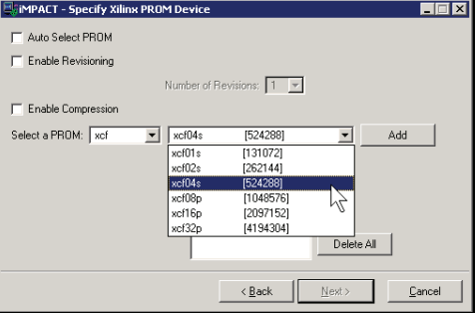

**Figure 2.24** Choose the XCF04S Platform Flash PROM

The PROM Formatter then echoes the settings, as shown in Figure 3-4. Click Finish.

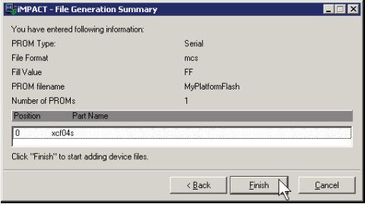

**Figure 2.25** Click Finish after Entering PROM Formatter Settings

1. The PROM Formatter then prompts for the name(s) of the FPGA configuration bitstreamfile. As shown in Figure 4-18, click OK to start selecting files. Select an FPGA bitstream file(*.bit). Choose No after selecting the last FPGA file. Finally, click OK to continue.

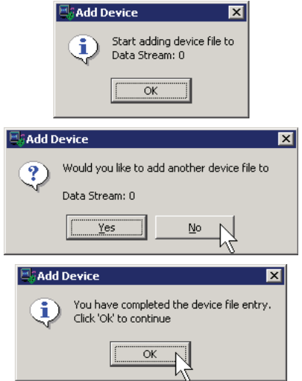

**Figure 2.26** Enter FPGA Configuration Bit stream File

When PROM formatting is complete, the iMPACT software presents the present settingsby showing the PROM, the select FPGA bitstream(s), and the amount of PROM spaceconsumed by the bitstream.

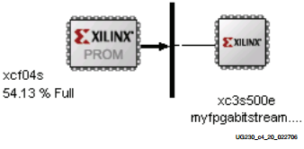

**Figure 2.27** PROM Formatting Completed

Figure 3-6 shows an example for a single XC3S500E FPGA bitstream stored in an XCF04S Platform Flash PROM. Now to generate the actual PROM file, click Operations and Generate File.

The iMPACT software indicates that the PROM file was successfully created, as shown inFigure 3-7.

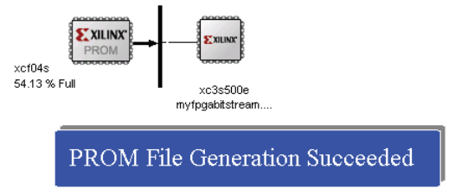

**Figure 2.28** PROM File Formatter Succeeded

1. Programming the Platform Flash PROM : - To program the formatted PROM file into the Platform Flash PROM via the on-board USBJTAG circuitry, follow the steps-

Place the iMPACT software in the JTAG Boundary Scan mode, either by choosingBoundary Scan in the iMPACT Modes pane, as shown in Figure 3-8, or by clicking onthe Boundary Scan tab.

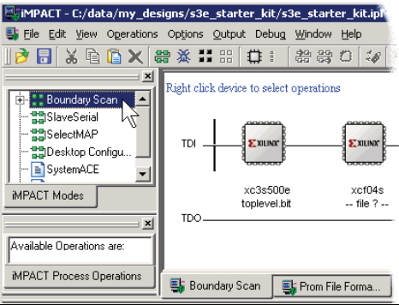

**Figure 2.29** Switch to Boundary Scan Mode

Assign the PROM file to the XCF04S Platform Flash PROM on the JTAG chain, as shown in Figure 3-9. Right-click the PROM icon, then click Assign New Configuration File.Select a previously generated PROM format file and click OK.

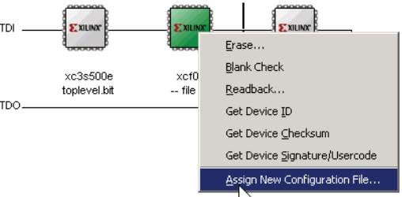

**Figure 2.30** Assign the PROM File to the XCF04S Platform Flash PROM

1. Now to start programming the PROM, right-click the PROM icon and then click Program.

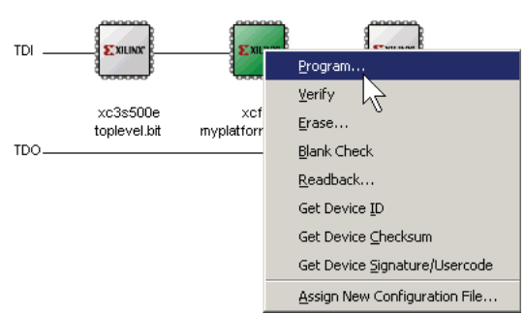

**Figure 2.31** Program the XCF04S Platform Flash PROM

**CHAPTER 3**

**LITERATURE SURVEY**

Jinye Zhang “Asynchronous FIFO Implementation Using FPGA” introduce a design of asynchronous FIFO on FPGA for the purpose of high-speed, steady data transmission between asynchronous clock domains. In the design, the memory address was organized into one ring list, using gray code as its address code, making uses of double jump technology to finish two asynchronous clock regions between address signals transmission, avoiding the meta-stability well...

Van de Goor “Fault Models and Tests for Ring Address” has proposed that First-in First-Out memories are becoming increasingly popular as buffer storage between subsystems operating at different data rates. One common way to implement a FIFO is to use a dual-port SRAM memory with a ring-address mechanism consisting of an n-bit shift register (n is the number of words in the FIFO). This saves the address decoder circuitry and allows for higher speed operation, which makes this type of FIFO very popular, especially for embedded applications. The well known functional tests for SRAMs cannot be applied to FIFOs because of their built-in access restrictions. Functional fault models and functional tests for Ring-Address Type FIFOs have not been studied and reported before; this paper aims at filling in this gap. It introduces functional fault models and presents a set of tests for Ring-Address Type FIFOs.

Ad J. van de Goor, Ivo Schanstra, Yervant Zorian proposed that FIFO memories impose special test problems because of their built-in addressing restrictions and access limitations. With the increasing use of FIFOs, as a stand-alone chip or as embedded macros in ASICs, generic algorithms are needed to test FIFOs. They addresses the problem of testing the widely available shifting-type FIFOs; it introduces specific fault models and a set of generic tests which have a test length of) and can be used for the stand alone chip as well as for the embedded macro version of the FIFO.

Nobutaro Shibata, Mayumi Watanabe “A current-sensed high speed and low-power first in first out memory using a wordline/bitline-swapped dual-port sram cell” proposed that First-in–first-out (FIFO) data storages are in great demand for telecommunication LSIs. This paper presents high-speed and low-power CMOS memory techniques specialized for FIFO operation. A size-configurable architecture using the tile methodology is employed to customize the word counts and/or data bits with a short time of less than 30 min. Four flag bits are introduced to inform the internal state of FIFO memories. To obtain a higher operating speed, an SRAM-like memory cell with current-sense readout is used. The critical-path delay of the Gray-code up/down counter, indicating the stored data volume, is shortened to 6.0 ns (66%) by using a double-rail single-stage XOR circuit. As to the low-power techniques, a wordline/bit-line-swapped dual-port memory-cell architecture is proposed to cut off the static power-supply current of unselected columns. By using the hidden blanket pre-charged bit line scheme, the power dissipation of the writing circuitry is minimized without de- grading the operating speed. A new data-driven gated-shift-pulse architecture is also proposed to reduce the power dissipation of shift-register-type address pointers (1.5 mW at 100 MHz). A 2K-words 8-bits FIFO memory test chip, fabricated with a 0.6 m CMOS process (a short effective channel length of 0.35 m is available for both the nMOS and pMOS), has demonstrated the 140-MHz operation at a typical 3.3-V power supply. The power dissipation in standby is less than 0.1 W and that at 100-MHz dual-port operation with single fan-out loads is in the range from28 mW (in the best case with the M-scan test pattern) to 46 mW (in the worst case with the checkerboard test pattern).

Van de Goor, “Asynchronous FIFO” presents a test method for testing two-D-flip-flop synchronizers in an asynchronous first-in-first-out (FIFO) interface. A faulty synchronizer can have different fault behaviors depending on the input application time, the fault location, the fault mechanism, and the applied clock frequency. The proposed test method can apply the input patterns at different time and generate capture clock signals with different frequency regardless of phase-locked loop (PLL) of the design. To implement the proposed test method, channel delay compensator, delayed scan enable signal generator, launch clock generator, and capture clock generator are designed. In addition, a well-designed calibration method is proposed to calibrate all programmable delay elements used in the test circuits. The proposed test method evolves to several test sections to detect all possible faults of the two-D-flip-flop synchronizers in the asynchronous FIFO interface.

Maritti Juhola, “Comparison of Algorithms for Standard Median Filtering,” proposed an asynchronous First-In-First-Out memory integrated circuit is equipped with a Built-In Self Test logic structure which allows extensive full-frequency asynchronous memory testing requiring minimal external test equipment. Memory input data patterns are generated by write data pattern circuitry responsive to a write clock signal. The write data generator considers the full status of the FIFO memory device. A read data generator provides an expected output data pattern corresponding to the data pattern provided by the write data generator responsive to a read clock signal such that the status of the FIFO memory device is taken into account. A read data error circuit compares the expected output data with the actual output data, indicating any mismatch between the two. Further this asynchronous First-In-First-Out memory device stores information regarding the nature of any mismatches and allows this information to be serially read from its output.

Application note virtex series presents that the virtex architecture supports powerful new configuration modes, including partial reconfiguration. These mechanisms are designed to give advanced applications access to and manipulation of on-chip data through the configuration interfaces. This is an overview of the virtex architecture, emphasizing data bit location in the configuration bit stream. Knowing bit locations is the basis for accessing and altering on-chip data. FPGA applications can be built that change or examine the functionality of the operating circuit without stopping the circuit loaded in the device.

Clifford E. Cummings “Synthesis and Scripting Techniques for Designing Multi-Asynchronous Clock Designs,” proposed an improved technique for FIFO design is to perform asynchronous comparisons between the FIFO write and read pointers that are generated in clock domains and asynchronous to each other. The asynchronous FIFO pointer comparison technique uses fewer synchronization flip-flops to build the FIFO. This method requires additional techniques to correctly synthesize and analyze the design. To increase the speed of the FIFO, this design uses combined binary/Gray counters that take advantage of the built-in binary ripple carry logic. This FIFO design is used to implement the AMBA AHB Compliant Memory Controller, which means, Advanced Microcontroller Bus Architecture compliant Microcontroller. The MC is designed for system memory control with the main memory consisting of SRAM and ROM.

Clifford E. Cummings and Peter Alfke, “Simulation and Synthesis Techniques for Asynchronous FIFO Design with Asynchronous Pointer Comparisons,” proposed an interesting technique for doing FIFO design is to perform asynchronous comparisons between the FIFO write and read pointers that are generated in clock domains that are asynchronous to each other. The asynchronous FIFO pointer comparison technique uses fewer synchronization flip-flops to build the FIFO. The asynchronous FIFO comparison method requires additional techniques to correctly synthesize and analyze the design, which are detailed in this paper.

To increase the speed of the FIFO, this design uses combined binary/Gray counters that take advantage of the built-in binary ripple carry logic. The fully coded, synthesized and analyzed RTL Verilog model is included. This FIFO design builds on information already presented in another FIFO design where the FIFO pointers are synchronized into the opposite clock domain before running "FIFO full" or "FIFO empty" tests.

**CHAPTER 4**

**ASYNCHRONOUS FIFO DESIGN**

**4.1 Types of FIFO**

Every memory in which the data word that is written in first also comes out first when the memory is read is a first-in first-out memory. Figure 1 illustrates the data flow in a FIFO. There are three kinds of FIFO:

* Shift register – FIFO with an invariable number of stored data words and, thus, the necessary synchronism between the read and the write operations because a data word must be read every time one is written.
* Exclusive read/write FIFO – FIFO with a variable number of stored data words and, because of the internal structure, the necessary synchronism between the read and the write operations.
* Concurrent read/write FIFO – FIFO with a variable number of stored data words and possible Asynchronism between the read and the write operation.

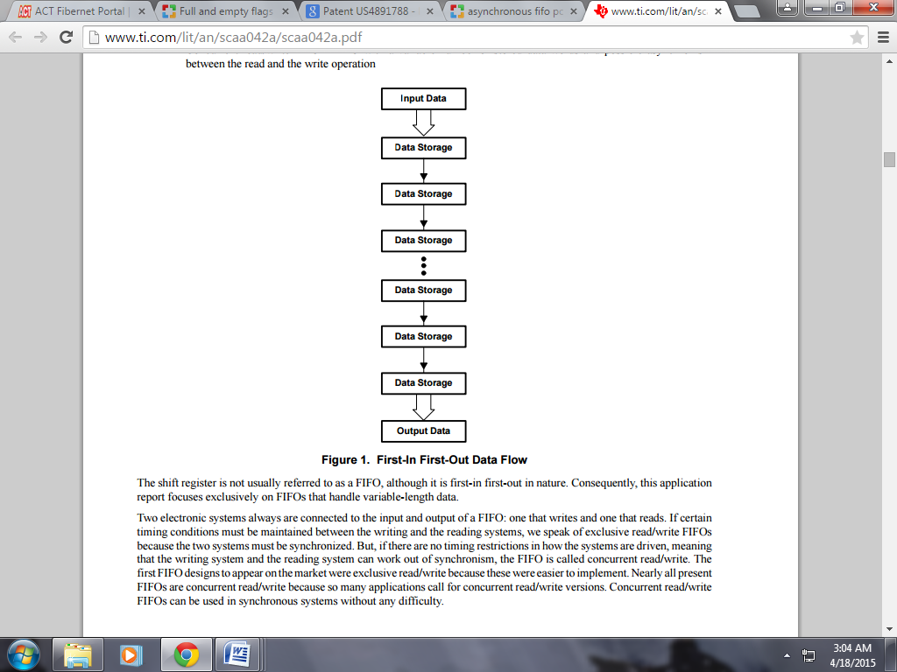

**Figure 4.1** First in first out Data Flow

The shift register is not usually referred to as a FIFO, although it is first-in first-out in nature. Consequently, this application report focuses exclusively on FIFOs that handle variable-length data. Two electronic systems always are connected to the input and output of a FIFO: one that writes and one that reads. If certain timing conditions must be maintained between the writing and the reading systems, exclusive read/write FIFOs are considered because the two systems must be synchronized. But, if there are no timing restrictions in how the systems are driven, meaning that the writing system and the reading system can work out of synchronism, the FIFO is called concurrent read/write. The first FIFO designs to appear on the market were exclusive read/write because these were easier to implement. Nearly all present FIFOs are concurrent read/write because so many applications call for concurrent read/write versions. Concurrent read/write FIFOs can be used in synchronous systems without any difficulty.

**4.1.1 Exclusive Read/Write FIFOs**

In exclusive read/write FIFOs, the writing of data is not independent of how the data are read. There are timing relationships between the write clock and the read clock. For instance, overlapping of the read and the write clocks could be prohibited. To permit use of such FIFOs between two systems that work asynchronously to one another, an external circuit is required for synchronization. But this synchronization circuit usually considerably reduces the data rate.

**4.1.2** **Concurrent Read/Write FIFOs**

In concurrent read/write FIFOs, there is no dependence between the writing and reading of data. Simultaneous writing and reading are possible in overlapping fashion or successively. This means that two systems with different frequencies can be connected to the FIFO. The designer need not worry about synchronizing the two systems because this is taken care of in the FIFO. Concurrent read/write FIFOs, depending on the control signals for writing and reading, fall into two groups:

i. Synchronous FIFOs

ii. Asynchronous FIFOs.

**4.2 Introduction to Asynchronous Design**

With the development of integrated circuit technology, the scale of circuit design is increasing rapidly and the system clock is also used more and more often. Including the handling of many asynchronous clocks, they will cause conflict quasi-steady signals, which may lead to the design function of the system failure. Therefore, treatment of asynchronous clock has been difficulties in circuit design. There are many solutions to this problem, such as the phase control method, double jump technology. However, these methods are low efficiency, the best approach is to use asynchronous clock asynchronous FIFO, which passes signals between the clock regions is more flexible and commonly used in the standard bus interface to transfer data between the memory read and write burst. We introduce a high-speed asynchronous FIFO method within the FPGA, according to the excellent control logic of FPGA, and low power consumption, high reliability, reconfigurability, short development cycle and lower development costs and so on. The method is suitable for high frequency data acquisition system, such as video image acquisition pretreatment systems.

**4.3 The Design of Asynchronous FIFO**

Asynchronous FIFOs are used as buffers between two asynchronous clock domains to exchange data safely. Data is written into the FIFO from one clock domain and it is read from another clock domain. This requires a memory architecture wherein two ports of memory are available- one is for input (or write or push) operation and another is for output (or read or pop) operation. Generally FIFOs are used where write operation is faster than read operation. However, even with the different speed and access types the average rate of data transfer remains constant. FIFO pointers keep track of number of FIFO memory locations read and written and corresponding control logic circuit prevents FIFO from either under flowing or overflowing. FIFO architectures inherently have a challenge of synchronizing itself with the pointer logic of other clock domain and control the read and write operation of FIFO memory locations safely. A detailed and careful analysis of synchronizer circuit along with pointer logic is required to understand the synchronization of two FIFO pointer logic circuits which is responsible for accessing the FIFO read and write ports independently controlled by different clocks.

**4.4 Issues in Designing Asynchronous FIFO**

It has been mentioned that designing of FIFO pointers for efficient working of FIFO is the key issue while designing FIFO architecture. Let us go deep into the FIFO read and write pointers. On reset both read and write pointers are pointing to the starting location of the FIFO. This location is also the first location where data has to be written at the same time this first location happens to be first read location. Therefore, in general we can say, read pointer always points to the word to be read and write pointer always points to the next location to which data has to be written.

Consider write operation. When both read and write pointers are pointing to first location of FIFO empty flag is asserted indicating the FIFO status as empty. Now data writing can be performed. Data will be written to the location where the write pointer is pointing and after the data write operation write pointer gets incremented pointing to the next location to be written. At the same time, empty flag is reasserted which indicates that FIFO is not empty, some data is available. One notable point regarding read pointer is with empty flag active the data pointed out by the read pointer is always invalid data. When first data written and empty flag status cleared (i.e. empty flag inactive) read pointer logic immediately drives the data from the location to which it was pointing to the read port of the dual port RAM, ready to be read by read logic. With this implementation of read logic the biggest advantage is that only one clock pulse is required to read from read port since previous clock cycle has already incremented read pointer and drives the data to read port. This will help in reducing latency in detecting empty and full pointer flag status. Empty status flag can be asserted in one more condition. After some n number of data write operations if same n number of read is performed then both pointers are again equal. Hence if both pointers “catch up” each other then empty flag is asserted.

Consider FIFO full status. When write pointer reaches the top of the FIFO, it is pointing towards the location, which can be written and is the last location to be written. No read operation is performed yet and read pointer is pointing to first location itself. This is one method is to generate FIFO full condition. When write pointer reaches the top of the FIFO, if full flag is asserted then it is not the actual FIFO full condition, this is only ‘almost full’ as there is one location which can be written. Similarly almost empty condition can exist in FIFO. Now a write operation causes the location to be written and increment of write pointer. Since the location was the last one write pointer wraps up to first location. Now both read and write pointers are equal and hence empty flag is asserted instead of full flag assertion, which is a fatal mistake. Hence wrap around condition of a full pointer may be a FIFO full condition.

After writing the data to FIFO (consider write pointer is in top of FIFO) some data has been read and read pointer is somewhere in between FIFO. One more write operation causes the write pointer to wrap. Note that even though write pointer is pointing to first location of FIFO this is NOT FIFO full condition, since read pointer has moved up from the first location. Further data writing pushes write pointer up. Imagine read pointer wraps around after some more read operation. Present condition is that both pointers have wrapped around but there is no FIFO full or FIFO empty condition. Data can be written to FIFO or read from the FIFO.

**4.5 Block Diagram of Asynchronous FIFO**

A FIFO is constructed in the FPGA using dual-port RAM. In the design, the difficult is to generate the empty and full flag, because the flag of input control is due to output, similarly the flag of output control is usually generated by input. Therefore, both the write address and read address must be re-synchronized when transfer to another area. Below is a simplified diagram of asynchronous FIFO.

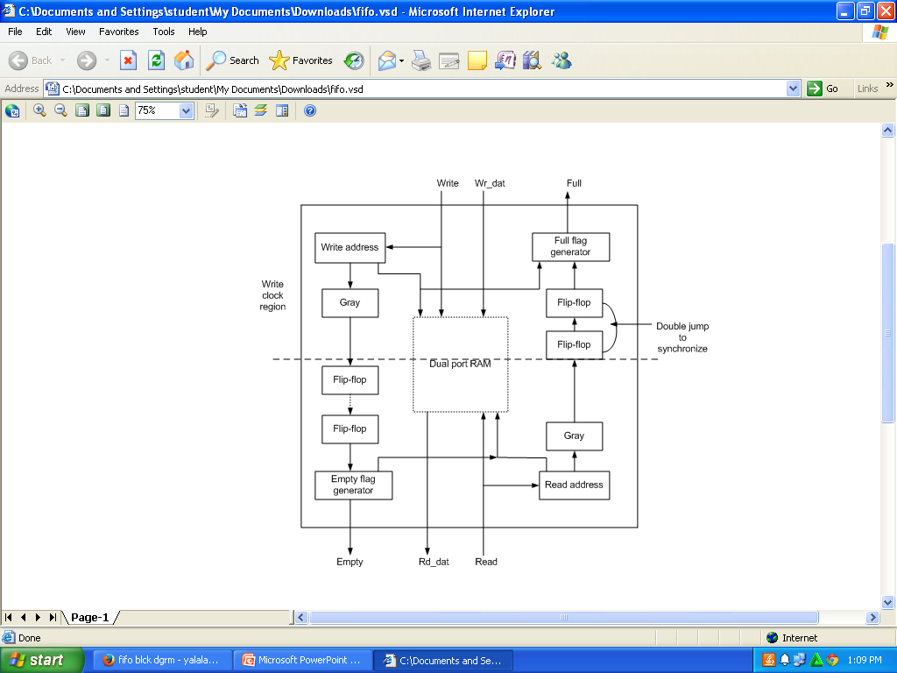

**Figure 4.2** Block Diagram of Asynchronous FIFO

Design of Asynchronous FIFO includes the following modules:

1. Dual-port RAM
2. State logic module
3. Gray Code Counter
4. Flag generation unit

**CHAPTER 5**

**DESCRIPTION OF MODULES**

**5.1 Dual port RAM introduction**

This is the heart of the FIFO whose width is 8 bits. It has two ports port A and port B. Port A is used as write port and port B is used as read port. A FIFO has the following inputs:

1. Write Data (8 bit)
2. Write Enable
3. Read Enable
4. Write Clock
5. Write address (4 bit)
6. Read Address(4 bit)

Outputs such as:

1. Read Data (8 bit)
2. Full Empty

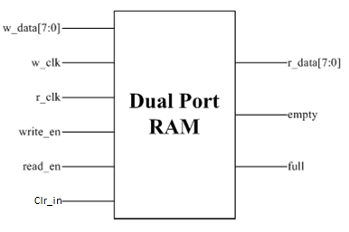

**Figure 5.1** Block Diagram of Dual-poet RAM

Data which is to be written and the address where it has to be written is supplied at the input port write data and write address. At the positive edge of the clock when Write enable is enabled so now the data is been written into the FIFO memory, now it has to be Read out, for that to happen Read enable should be Enabled and the address from which the data has to be read should be specified at the input port Read address. This is the memory operation in brief, now we have to control the memory in such a way that it meets the requirements of the FIFO.

 Asynchronous dual-port RAM devices are memory devices with non-clocked inputs and outputs for data, address, and control functions. These dual-ported RAMs respond to address and control pin changes without the need for clocks or counters while allowing simultaneous access to a single static SRAM memory location from two buses. Most asynchronous dual- port RAMs also have arbitration logic.

1. Dual- port RAM increases bandwidth (~2x SRAM)
2. Dual-port RAM reduces design complexity
3. Dual-port RAM shortens time-to-market compared to alternative solutions

The dual-port memory portion of the FIFO can be realized with a dual-port RAM cell that has a plurality of addressable locations. The read and write pointers are provided for generating the addresses of the addressable locations for the read and write operations, respectively. The read and write pointers are incremented for a read and write operation, respectively, instead of actually moving the data through a series of shift registers. However, it is important that the read pointer and write pointer do not point to the same address at the same time wherein information would be written into a memory location and read from the same memory location simultaneously. To prevent this happening, status flags are utilized to provide an indication to the user of the proximity of the two pointers.

A Dual-port RAM is a random-access memory that can be accessed simultaneously by two independent entities. In digital ICs, this implies a dual-port memory cell that can be accessed at the same time using two independent sets of address, data, and control lines. Dual port RAM can read and write different memory cells simultaneously at different addresses. This is the main difference between dual port RAM and single port RAM, as single port RAM can only be accessed at one address at a time. Therefore, single port RAM allows only one memory cell to be read/write during each clock cycle. Also, single port RAM uses a 6 transistor basic ram cell, whereas a dual port ram cell uses an 8 transistor cell for memory. This means that the area of a single port RAM cell is smaller than the area of a dual port RAM cell.

**5.1.1 Port Definition**

**Table 5.1** Signals and their definitions:

|  |  |  |  |
| --- | --- | --- | --- |
| **Signal name** | **Port definition** | **Port width** | **Port description** |
| w_clk | Input | 1 | Clock for write domain operations |
| r_clk | Input | 1 | Clock for read domain operations |
| clr_in | Input | 1 | Used to clear data |
| write_en | Input | 1 | Used to enable write operation |
| read_en | Input | 1 | Used to enable read operation |
| Write_data | Input | 8 | Used to write data |
| Read_data | Output | 8 | Used to read data |
| Full | Output | 1 | High when the FIFO is full |
| Empty | Output | 1 | High when FIFO is empty |

**5.1.2 Write port**

Write port allows the data to enter into FIFO. It has 3 inputs namely, w_data, w_clk, write_en, and an output called full. Data can be written (w_data) only if the FIFO is not full and write_en=1 at posedge w_clk; else a full signal output is shown.



**Figure 5.2** Write port

**5.1.3 Read port**

Read port allows the data to read from FIFO. It has 2 inputs namely, r_clk, read_en, and 2 outputs namely r_data, empty. Data can be read (r_data) only if the FIFO is not empty and read_en=1 at posedge r_clk; else an empty signal output is shown.



**Figure 5.3** Read port

**5.1.4 Dual-Port Memory using Single-Port Ram**

Before the dual-port memory cell existed, designers created dual-port RAMs from single-port RAMs by adding multiplexer between the RAM and the two entities that shared the RAM. Figure 1 illustrates a block diagram of such an arrangement. Two processors, MP1 and MP2, share the RAM. If each processor has access to the RAM half the time, the resource is shared equally and is said to be allocated according to a fairness doctrine. This time division multiplexing assures that there is no contention for the RAM. However, performance suffers if the RAM’s access time does not equal 1/2 or less of the processors’ clock period, assuming that the processors are clocked from the same source.



**Figure 5.4** Block Diagram of single-port RAM

This approach requires either single-port memories with access times equal to one half of a bus cycle time, or requires that each processor access the RAM on every other cycle. Often these requirements are limiting due to speeds of available RAMs and difficulties with interleaving transactions between processors. Note also that this approach requires both processors to be running from the same clock. By using dual-ported RAMs, the efficiency of memory accesses can essentially be doubled. Also since Dual-port RAMS do not have restrictions regarding accesses between the two ports, each processor can be operating at different clock rates. This inherent synchronization property proves to be one of the largest benefits of using dual-port RAMs.

**5.1.5 Virtual Dual-port RAM**

Communication between systems does not require physical dual-port RAMs. Instead, a conventional RAM memory is partitioned into virtual data-storage areas (buffers), usually to store at least two data packets. These buffers are shared between the communications controller and the intelligent element that assembles the packets and stores them (usually a microprocessor). The communication controller can also be a microprocessor. It reads the data from memory, converts the data from parallel to serial form, encodes the data, converts the data to analog form, and sends the data out over the communications channel on the transmit side. If the system contains only one processor, the data buffers are not shared, and the system needs neither a virtual nor a physical dual-port RAM. Control information associated with each data buffer tells the communications controller the number of words in the buffer and the starting address of the data in the buffer systems.

**5.1.6 Functional Description**

At reset, the pointers are both 0. This is the empty condition of the FIFO, and empty is pulled high (we will use the active high convention) and full is low. At empty, reads are blocked and so the only operation possible is write. A write loads location 0 of the array and increments the write pointer to 1. This causes the empty signal to go LOW. Assuming that there are no reads and subsequent cycles only write to the FIFO, there will be a time when the write pointer will equal array_size -1. This means that the last location in the array is the next location that will be written to. At this condition, a write will cause the write pointer to become 0, and set full. Note that in this condition the write and read pointers are equal, but the FIFO is full, and not empty. This implies that the full/empty decision is not based on the pointer values alone, but on the operation that caused the pointers to become equal. If the cause of pointer equality is a reset or a read, the FIFO is deemed empty; if the cause is a write, the FIFO is full.

Now assume that we begin a series of reads. Each read will increment the read pointer, to the point where the read pointer equals array_size -1. At this point, the data from this location is available on the output bus of the FIFO. Succeeding logic reads this data and provides a read signal (active for one clock). This causes the read pointer to become equal to the write pointer again (after both pointers have completed one cycle through the array). However, since this equality came about because of a read, empty is set. A write unconditionally clears empty. A read unconditionally clears full.

Thus, we have the following for the empty flag:

read_pointer = (array_size -1) and a read sets empty.

and the following for the full flag:

write_pointer = (array_size -1) and a write sets full.

However, this is a special case, since in general reads may start as soon as the FIFO is not empty (the reading logic need not wait for the FIFO to become full), so these conditions have to be modified to accommodate any read_pointer and write_pointer values.

It is seen that the array is organized as a circular list. Thus, if the write pointer is numerically greater than the read pointer by 1 and a read occurs, the FIFO is empty. This works just fine for the boundary case described above as long as we use unsigned (n-bit) arithmetic. Similarly, if the read pointer is numerically greater than the write pointer by 1 and a write occurs, the FIFO is full.

This leads to the conditions: A write unconditionally clears empty.

(write_pointer = read_pointer + 1) and a read sets empty.

A read unconditionally clears full.

(read_pointer = write_pointer + 1) and a write sets full.

Note that a simultaneous read and write increments both pointers, but does not alter the state of the empty and full flags. A simultaneous read and write is not allowed at the full and empty boundaries. With this we can now define the status block of the FIFO.

**5.1.7 FIFO Depth Calculations**

FIFO is used as buffering element or queuing element in the system, which is by common sense is required only when you slow at reading than the write operation. So size of the FIFO basically implies the amount of data required to buffer, which depends upon data rate at which data is written and the data rate at which data is read. Statistically, Data rate varies in the system majorly depending upon the load in the system. So to obtain safer FIFO size we need to consider the worst case scenario for the data transfer across the FIFO under consideration.

|  |
| --- |
|  |
| 1. In the worst case scenario, difference between the data rates of write and read should be maximum. Hence, for write operation maximum data rate should be considered and for read operation minimum data rate should be considered. 2. Data rate of read operation is specified by the number of idle cycles and for write operation, maximum data rate should be considered with no idle cycle. 3. So for write operation, we need to know Data rate = Number of data * rate of clock. Writing side is the source and reading side becomes sink, data rate of reading side depends upon the writing side data rate 4. In order to know the data rate of write operation, we need to know Number of data in a Burst which we have assumed to be B.   So following up with the equation as explained below:  **D = [B - (clk_rd/clk_wr)*(B)*(1/RD)]**  where,  D = Depth or number of locations in FIFO to store.  B = Burst Width, number of words to store before idle time.  Clk_rd = Read side clock frequency.  Clk_wr = Write side clock frequency.  RD = Read side delay in-between reads.  **5.1.7.1 Example for FIFO depth Calculation**  i. Write side of FIFO:  Write clock frequency = 15 MHz (clk_wr)  Maximum size of the Burst = 100 bytes (burst_width)  Delay between writes in a burst = 1 clock cycle (wr_delay)  ii. Read side of FIFO:  Read clock Frequency = 10 MHz (clk_read)  Delay between reads = 2 clock cycles (rd_delay)  Six step approach to calculate FIFO parameters:  Step 1: FIFO Width = 8 (1 byte = 8 bits worth of data at each buffer location)  Step 2: Assume depth of FIFO to capture the complete buffer = 100 (maximum size of burst)  Step 3: No of write clock cycles for writing 100 locations in FIFO = 100 @ clk_wr  Step 4: Time taken to write 100 locations = 100/(15*10^6) = 6.67 us  Step 5: No of reads during 6.67 us = (6.67 us) * 10 * 106 = 66.7 @ clk_read (approx 67)  Step 6: No of dead cycles between reads = 2.  Depth of the FIFO = 100 – 66.7/2 = 100 – 33.35 = 66.65 = 67  **5.1.8Applications of FIFO**  The first applications for dual-port memories were for CPU register files. Dual-port RAMs can also serve as data or instruction cache memories. However, the largest usage of dual-port RAMs is in communications, which includes the exchange of data between processors, processes, and systems.  **5.2 State Logic Module**  State logic module task is to provide FIFO empty and full flag signal, this signal tells the external circuit FIFO has reached a critical condition: if there is full signal, then the FIFO write operation for the critical state, that there is no space to store more data; if there is an empty signal, the FIFO read operation for the critical state that no more data FIFO can be read. So empty, FIFO full signal is a very important role to play, read and write it in order to achieve their own independent operation and management of obstructive data storage. We can list the memory organized into a ring, for the empty or full of signs can be read, write, to get the relative position of the address.  System reset, read, write addresses are 0, which is FIFO empty status, not allowed to read. To the F IFO reading and writing data in the process, read, write, change of address was increasing, if the write address and read address difference is greater than I or more to be read until FIFO empty so far; the same token, if you write address and read address difference is greater than 1 or more to write, until the FIFO is full. Because memory is organized into a ring form, so when writing the address or read address 1023, the next read, write operation, read, write, will jump to address 0, this work ways are used to describe the structure of the unsigned critical state is very suitable.    **Figure 5.5** Ring Address  **5.2.1 Introduction**  The status flags are utilized on the read side to indicate to the user that the FIFO is empty. In this manner, the user would not attempt to read a FIFO that is empty and, in fact, circuitry is provided to inhibit incrementing of the read pointer to overtake the Write pointer address.  In a similar manner, a full flag is provided to indicate to the user that the memory is full, such that the user will not attempt to write data to the memory or increment the pointer past the read pointer. The full and empty status flags are conventional flags that are provided in FIFOs.  **5.2.2 Full & empty detection**  As with any FIFO design, correct implementation of full and empty is the most difficult part of the design. There are two problems with the generation of full and empty. First, both full and empty are indicated by the fact that the read and write pointers are identical. Therefore, something else has to distinguish between full and empty. One known solution to this problem appends an extra bit to both pointers and then compares the extra bit for equality (for FIFO empty) or inequality (for FIFO full), along with equality of the other read and write pointer bits. Another solution, the one described in this paper, divides the address space into four quadrants and decodes the two MSBs of the two counters to determine whether the FIFO was going full or going empty at the time the two pointers became equal.    **Figure 5.6** FIFO is going full because the wptr trails the rptr by one quadrant  If the write pointer is one quadrant behind the read pointer, this indicates a "possibly going full" situation. When this condition occurs, the direction latch is set. |
|  |  |  |
|  |  |  |
| **Figure 5.7** FIFO is going empty because the rptr trails the wptr by one quadrant  If the write pointer is one quadrant ahead of the read pointer, this indicates a "possibly going empty" situation. When this condition occurs, the direction latch is cleared.  The below figure illustrates the possibly going empty situation. |  |  |
|  |  |  |
|  |  |  |

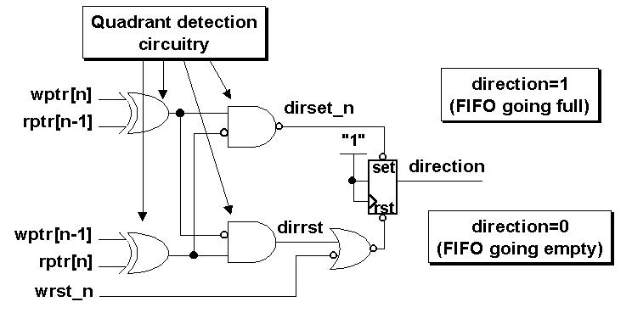

**Figure 5.8** Direction Latch

**5.2.3 Asynchronous the full/empty comparison logic**

Async _cmp is an asynchronous comparison module, used to compare the read and write pointers to detect full and empty conditions.

**5.2.3.1 Asynchronous generation of full and empty**

In the async_cmp aempty_n and afull_n are the asynchronously decoded signals. The aempty_n signal is asserted on the rising edge of an rclk, but is de-asserted on the rising edge of a wclk. Similarly, the afull_n signal is asserted on a wclk and removed on an rclk.

The empty signal will be used to stop the next read operation, and the leading edge of aempty_n is properly synchronous with the read clock, but the trailing edge needs to be synchronized to the read clock. This is done in a two-stage synchronizer that generates rempty.

The wfull signal is generated in the symmetrically equivalent way.

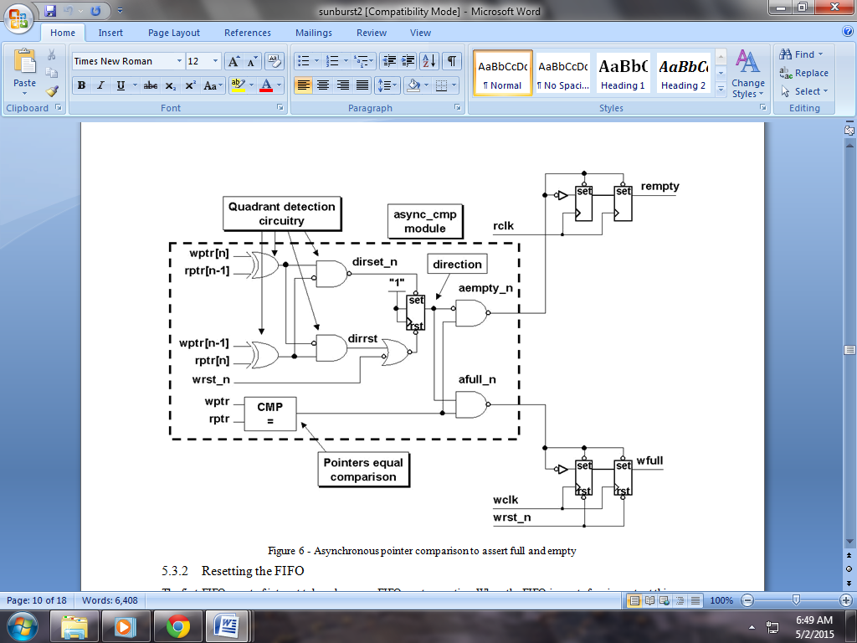

**Figure 5.9** Asynchronous pointer comparison to assert full and empty

**5.2.3.2 Resetting the FIFO**

The first FIFO event of interest takes place on a FIFO-reset operation. When the FIFO is reset, four important things happen within the async_cmp module and accompanying full and empty synchronizers of the wptr_full and rptr_empty modules:

1. The reset signal directly clears the wfull flag. The rempty flag is not cleared by a reset.
2. The reset signal clears both FIFO pointers, so the pointer comparator asserts that the pointers are equal.
3. The reset clears the direction bit.
4. With the pointers equal and the direction bit cleared, the aempty_n bit is asserted, which presets the rempty flag.

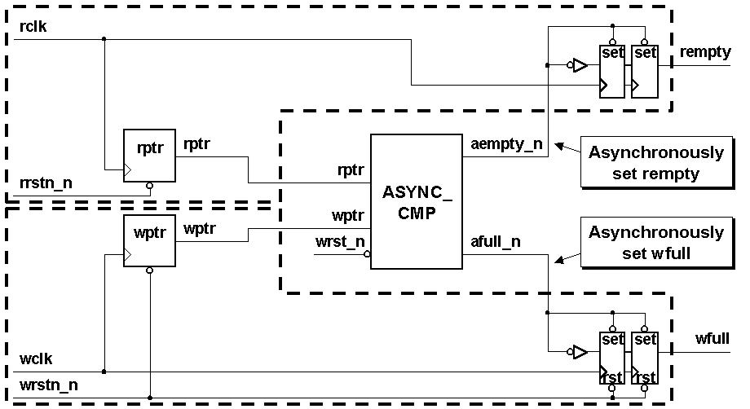

**Figure 5.10** Async_cmp module connection to rptr_empty and wptr_full modules

**5.2.4 FIFO-writes & FIFO full**

1. The first FIFO operational event of interest takes place when a FIFO-write operation takes place and the wptr is incremented. At this point, the FIFO pointers are no longer equal so the aempty_n signal is de-asserted, releasing the preset control of the rempty flip-flops. After two rising edges on rclk, the FIFO will de-assert the rempty signal. Because the de-assertion of aempty_n happens on a rising wclk and because the rempty signal is clocked by the rclk, the two-flip-flop synchronizer as shown in Figure 8 is required to remove meta-stability that could be generated by the first rempty flip-flop.
2. The second FIFO operational event of interest takes place when the wptr increments into the next Gray code quadrant beyond the rptr. The direction bit is cleared (but it was already clear).
3. The third FIFO operational event of interest occurs when the wptr is within one quadrant of catching up to the rptr when this happens; the dirset_n bit of Figure 6 is asserted low, which sets the direction bit high. This means that the direction bit is set long before the FIFO is full and is not timing-critical to assertion of the afull_n signal.
4. The fourth FIFO operational event of interest is when the wptr catches up to the rptr (and the direction bit is set). When this happens, the afull_n signal presets the wfull flip-flops. The afull_n signal is asserted on a FIFO-write operation and is synchronous to the rising edge of the wclk; therefore, asserting full is synchronous to the wclk.
5. The fifth FIFO operational event of interest is when a FIFO-read operation takes place and the rptr is incremented. At this point, the FIFO pointers are no longer equal so the afull_n signal is de-asserted, releasing the preset control of the wfull flip-flops. After two rising edges on wclk, the FIFO will de-assert the wfull signal. Because the de-assertion of afull_n happens on a rising rclk and because the wfull signal is clocked by the wclk, the two-flip-flop synchronizer, shown in Figure 8, is required to remove meta-stability that could be generated by the first wfull flip-flop capturing the inverted and asynchronously generated afull_n data input.

**5.2.5 FIFO-read & FIFO empty**

1. The sixth FIFO operational event of interest takes place when the rptr increments into the next Gray code quadrant beyond the wptr. The direction bit is again set (but it was already set).
2. The seventh FIFO operational event of interest occurs when the rptr is within one quadrant of catching up to the wptr. When this happens, the direct bit of Figure 6 is asserted high , which clears the direction bit. This means that the direction bit is cleared long before the FIFO is empty and is not timing critical to assertion of the aempty_n signal.
3. The eighth FIFO operational event of interest is when the rptr catches up to the wptr (and the direction bit is zero). When this happens, the aempty_n signal presets the rempty flip-flops. The aempty_n signal is asserted on a FIFO-read operation and is synchronous to the rising edge of the rclk; therefore, asserting empty is synchronous to the rclk. See section 5.3.6 for a discussion of the critical timing path associated with assertion of the rempty signal.

Finally, when a FIFO-write operation takes place and the wptr is incremented. At this point, the FIFO pointers are no longer equal so the aempty_n signal is de-asserted, releasing the preset control of the rempty flip-flops. After two rising edges on rclk, the FIFO will de-assert the rempty signal. Because the de-assertion of aempty_n happens on a rising wclk and because the rempty signal is clocked by the rclk, the two-flip-flop synchronizer as shown in Figure 8 is required to remove meta stability that could be generated by the first rempty flip-flop.

**5.3 Gray Code Counter**

Gray code is the code with only one bit transition between adjacent words. The direct description of Gray counter is based on the equation extraction from the truth table. Such solution of n-bit counter demands 2n-2 product terms. Implementation may be difficult for greater width of counter. The alternative is the using of the auxiliary bit. This bit is changed every clock period and corresponds to bit 0 of a binary counter. With assumption that the auxiliary bit extends Gray code word to the right, the particular bit is changed whenever the less significant bits create word 1,0,…0. The exception is MSB which is changed in addition by word 0,…0. Another description of Gray counter use conversion of Gray code to binary code. After the increment is done in binary code, the back conversion follows.

**5.3.1 Generation of Gray code**

Actually when we are moving between states in a standard binary sequence, multiple bits may change from 0 to 1 or vice versa; for example, three bits change value when moving from 0011 to 0100. In the physical world, there is no way to ensure that all the bits will transition at exactly the same time, so a system may actually pass through a sequence of intermediate states. For example, an intended state change of 0011 to 0100 could actually result in the sequence 0011 to0111 to 0100.

One way to avoid this problem is to use a Gray code, in which only a single bit changes when moving between states.

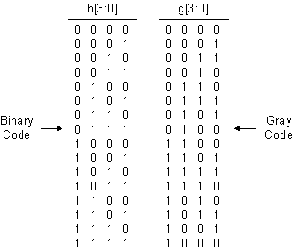

**Figure 5.11** 4-bit binary code versus 4-bit Gray code.

**5.3.2 Binary-to-Gray and Gray-to-Binary conversions**

It is often required to convert a binary sequence into a Gray code or vice versa. Such converters are easy to create and it is separated by the respective radio button.

**5.3.2.1 Binary-to-Gray code conversion**

1. This conversion method strongly follows the operation of Exclusive-OR gate. The following steps let you know how to achieve Binary Code to Gray number conversion.  
    The left most significant bit of a given Binary code number is same as the most left significant bit of the Gray number.
2. To obtain the successive Gray bits to produce the equivalent Gray number for the given binary code number, x-or the first bit of binary code to the second one and write down the result next to the first bit, x-or the second binary code bit to third one and write down the result and so on next to the second bit and repeat the same operation until the last bit.

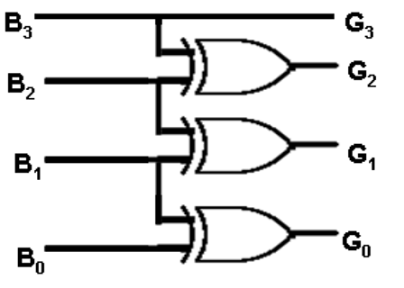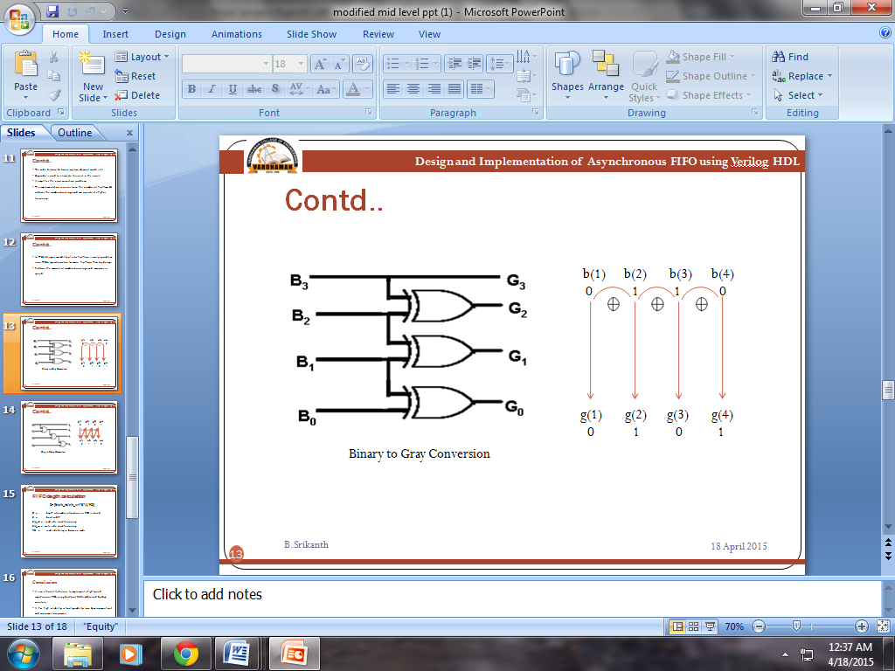

**Figure 5.12** Binary-to-Gray converter.

**5.3.2.2 Gray-to-Binary code conversion**

This conversion method strongly follows the operation of Exclusive-OR gate. The following steps let you know how to achieve Gray Code to Binary number conversion.  
1. The left most significant bit of a given grey code number is same as the most left significant bit of the binary number  
2. To obtain the successive binary bits to produce the equivalent binary number for the given grey code number, x-or the first bit output of grey code to the second gray one and write down the result next to the first bit, x-or the second output grey code bit to third gray one and write down the result and so on next to the second bit and repeat the same operation until the last bit.

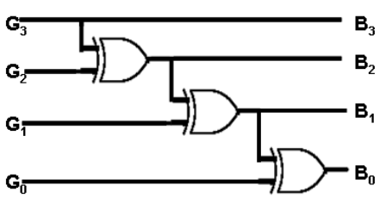 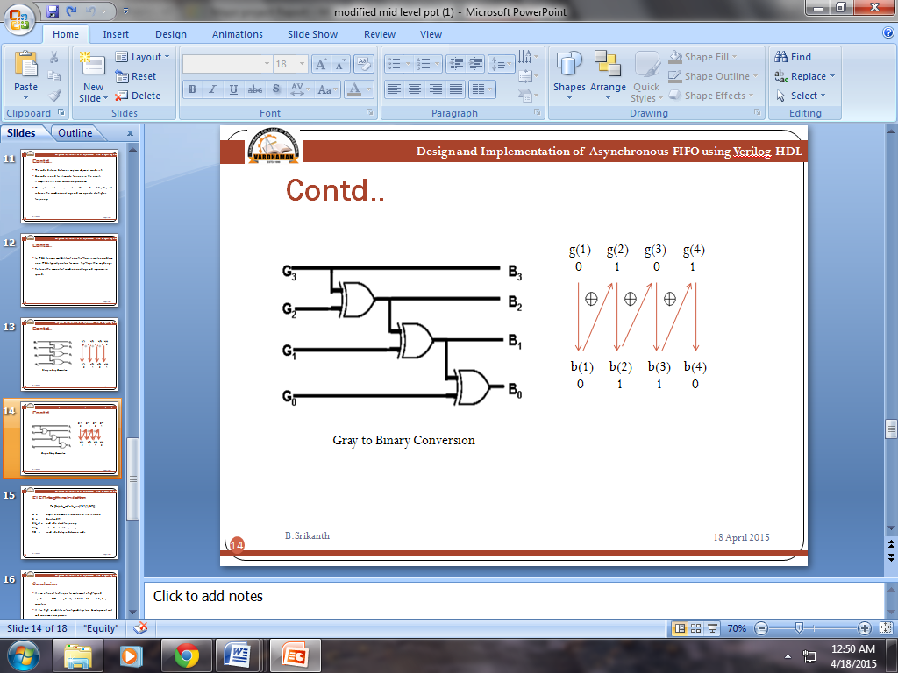

**Figure 5.13** Gray-to-Binary converter.

**5.3.3 Gray counter**

FPGA chip is the input and output modules (Input / Output Block, lOB), can be configured module (Configurable Logic Block, CLB) and programmable connection resources (Programmable Interconnect Array, PIA) 3 modules to form. PIA is located between the chip's logic blocks, underwent programmed into a network connection, internal logic for the connection between the chip and transfer information between them. As input to the logical block address the alignment may be different, so each bit of the address change counter cannot be completely synchronized, the address data may be in a period of instability. If the asynchronous clock is just the address in the address instability in the comparison when sampling, then it may output the wrong result. Therefore, the design refers to Gray code, Gray code is only one among the adjacent count encoding changes, the address counter with a Gray code can be done to eliminate fuzziness in the circuit, so as to solve the above problems and its implementation block diagram is shown below.



**Figure 5.14** Conversion figure

Gray code counters are of interest for a variety of applications, such as representing the state variables in state machines or acting as pointers in First-In First-Out (FIFO) memories. This is because only one output bit is ever toggling at a time in a Gray code "counter", as opposed to possibly multiple bits in a binary counter.

In addition to preventing intermediate states, Gray code counters consume only half the power of an equivalent binary counter and they generate correspondingly less noise. Actually, while the power and average noise difference between a Gray and a binary counter asymptotically approaches two, the peak noise difference is equal to the number of bits, since a Gray counter toggles only one bit at a time while a binary counter toggles all of its bits simultaneously two times over the course of a full-count cycle with fewer bits toggling proportionally more times.

**5.3.4 Implementing a Gray code counter**

Suppose we wish to generate a Gray code that can be used to index into a memory array. For example, suppose we're implementing something sort-of like a FIFO, and that we simply wish to keep on cycling through all of the memory locations. The point is that we aren't particularly concerned as to the order in which we address the locations, just that we sequence our way through them visiting each one a single time before returning to the first location to do it all over again.

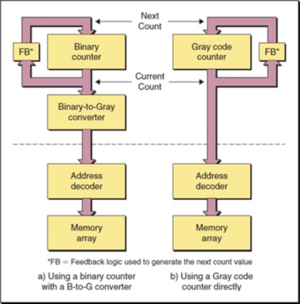

**Figure 5.15** Two techniques for generating a Gray code sequence.

Assuming that we're dealing with a 16-word memory array, one scenario [as illustrated in Figure 6.3.1 starts with a standard 4-bit binary counter, in which the current count value is passed through a chunk of feedback logic to generate the next count value. Also, the current count value is passed through a Binary-to-Gray converter to generate a corresponding Gray code.

**5.3.4.1 Generating sub-2n Gray code count sequences**

Consider a 4-bit binary counter. Multiple bits may change when transitioning from one value to another. For example, four bits change when one of the pointers transitions from 01112 to 10002. If multiple bits transitioning will cause us problems, we may decide to use a Gray code counter, in which only one bit changes as we transition from one value to another.

Observe that when we reach the final (maximum) Gray code value of 10002, the next count will return us to our initial value of 00002, which means that – as we expect – only a single bit changes for this transition.

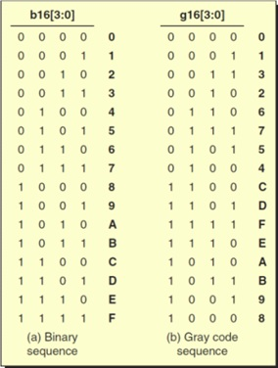

**Figure 5.16** Binary versus Gray codes

Now, suppose that instead of sequencing through all 16 values, for some reason we actually wish to cycle through only 10 words. If we use our original Gray code, the sequence will now be as follows: 00002, 00012, 00112, 00102, 01102, 01112, 01012, 01002, 11002, and 11012. The problem is that three bits will change value on the next transition, which will return us to our starting value of 00002 from our current value of 11012. So, is it possible to create a Gray code sequence for any non-power-of-2 number (so long as it is an even number)?

**5.3.5 Dual n-bit Gray code counter**

A Gray code counter uses two sets of registers, one a binary counter and a second to capture a binary-to-Gray converted value. The intent of this Gray code counter is to utilize the binary carry structure, simplify the Gray-to-binary conversion; reduce combinational logic, and increase the upper frequency limit of the Gray code counter. The binary counter conditionally increments the binary value, which is passed to both the inputs of the binary counter as the next-binary-count value, and is also passed to the simple binary-to-Gray conversion logic, consisting of one 2-input XOR gate per bit position. The converted binary value is the next Gray-count value and drives the Gray code register inputs.

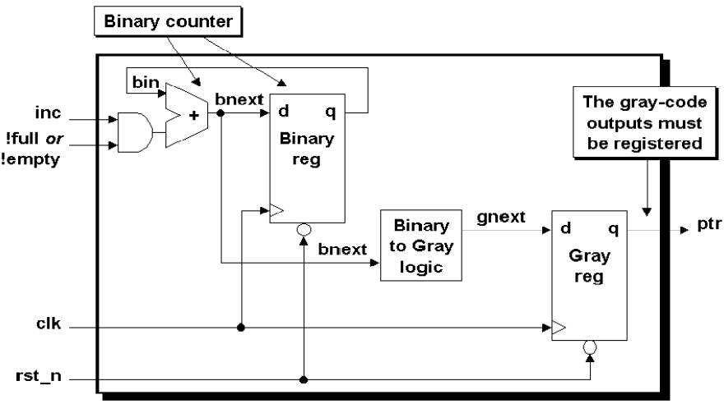

**Figure 5.17** Dual n-bit Gray code counters

This implementation requires twice the number of flip-flops, but reduces the combinatorial logic and can operate at a higher frequency. In FPGA designs, availability of extra flip-flops is rarely a problem since FPGAs typically contain far more flip-flops than any design will ever use. In FPGA designs, reducing the amount of combinational logic frequently translates into significant improvements in speed. The pointer output of the block diagram in the figure is an n-bit Gray code pointer.

Since the MSB of a binary sequence is equal to the MSB of a Gray code sequence, this design can be further simplified by using the binary MSB-flip-flop as the Gray code MSB-flip- flop.

**5.3.6 Flip-flops**

The type of flip flop used is D-type Flip Flop. The D Flip Flop is by far the most important of the [Clocked Flip-flops](http://amazon.in/s/?field-keywords=Sequential+Logic%3A+Analysis+and+Synthesis) as it ensures that ensures that inputs S and R are never equal to one at the same time. The D-type flip flop is constructed from a gated SR flip-flop with an inverter added between the S and the R inputs to allow for a single D (data) input.

**5.3.6.1 Logic symbol:**

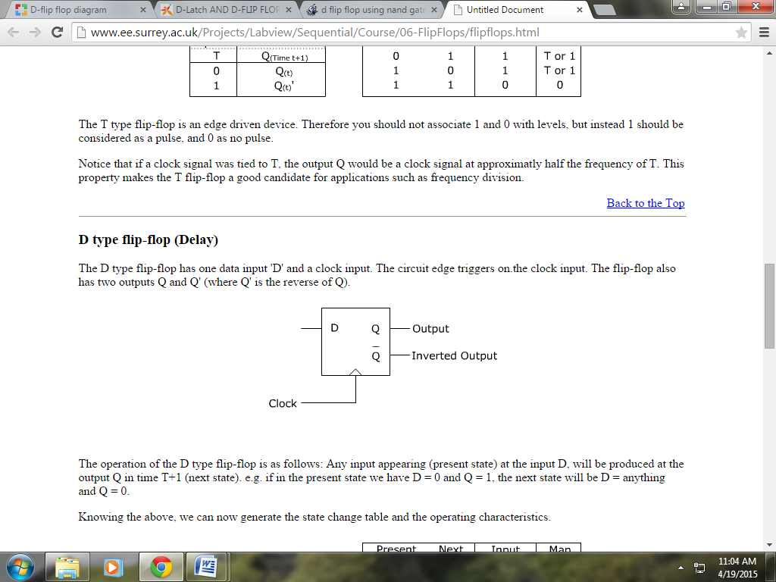

**Figure 5.18** D Flip-Flop

**Table 10.1** Truth table for D flip-flop

|  |  |  |  |  |
| --- | --- | --- | --- | --- |
| Clk | D | Q | Q` | Description |
| ↓ » 0 | X | Q` | Q | Memory  no change |
| ↑ » 1 | 0 | 0 | 1 | Reset Q » 0 |
| ↑ »1 | 1 | 1 | 0 | Set Q » 1 |

**5.3.6.2 Working of D Flip-flops**

The working of D flip flop is similar to the D latch except that the output of D Flip Flop takes the state of the D input at the moment of a positive edge at the clock pin (or negative edge if the clock input is active low) and delays it by one clock cycle. The D FlipFlop can be interpreted as a delay line or zero order hold. The advantage of the D flip-flop is that the signal on the D input pin is captured the moment the flip-flop is clocked, and subsequent changes on the D input will be ignored until the next clock event.

**5.3.6.3 Timing Diagram of D flip-flop**

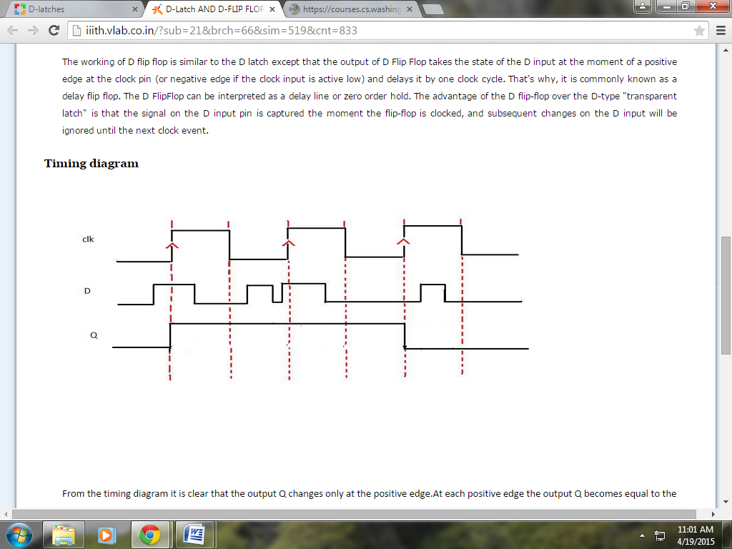

**Figure 5.19** Timing diagram of D Flip-flop

**5.4 Flag Generation Unit**

**5.4.1 Handling Full & Empty Conditions**

The FIFO design in this paper assumes that the empty flag will be generated in the read-clock domain to insure that the empty flag is detected immediately when the FIFO buffer is empty, that is, the instant that the read pointer catches up to the write pointer (including the pointer MSBs).

The FIFO design in this paper assumes that the full flag will be generated in the write-clock domain to insure that the full flag is detected immediately when the FIFO buffer is full, that is, the instant that the write pointer catches up to the read pointer (except for different pointer MSBs).

**5.4.1.1 Generating Empty**

The FIFO is empty when the read pointer and the *synchronized* write pointer are equal. Pointers that are one bit larger than needed to address the FIFO memory buffer are used. If the extra bits of both pointers (the MSBs of the pointers) are equal, the pointers have wrapped the same number of times and if the rest of the read pointer equals the synchronized write pointer, the FIFO is empty.

**5.4.1.2 Generating Full**

Since the full flag is generated in the write-clock domain by running a comparison between the write and read pointers, one safe technique for doing FIFO design requires that the read pointer be synchronized into the write clock domain before doing pointer comparison.

The full comparison is not as simple to do as the empty comparison. Pointers that are one bit larger than needed to address the FIFO memory buffer are still used for the comparison, but simply using Gray code counters with an extra bit to do the comparison is not valid to determine the full condition. The problem is that a Gray code is a symmetric code except for the MSBs.

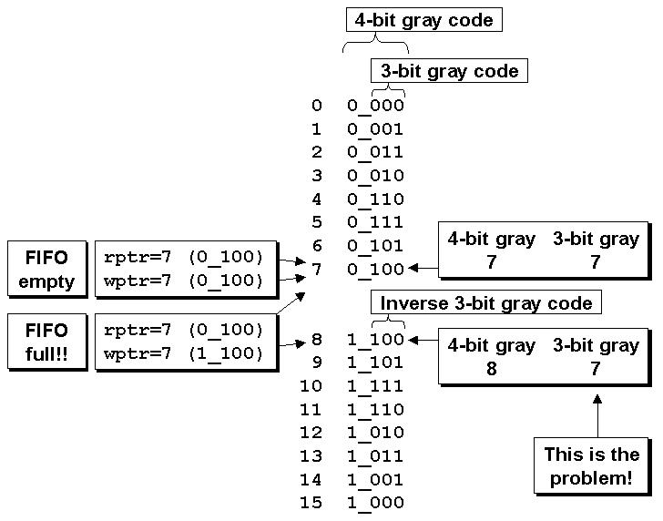

**Figure 5.20** Problems associated with extracting a 3-bit Gray code from a 4-bit Gray code

Consider the example of an 8-deep FIFO. In this example, a 3 -bit Gray code pointer is used to address memory and an extra bit (the MSB of a 4-bit Gray code) is added to test for full and empty conditions.

The correct method to perform the full comparison is accomplished by synchronizing the rptr into the wclk domain and then there are three conditions that are all necessary for the FIFO to be full:

* 1. The wptr and the synchronized rptr MSB's are not equal (because the wptr must have wrapped one more time than the rptr).
  2. The wptr and the synchronized rptr 2nd MSB's are not equal (because an inverted 2nd MSB from one pointer must be tested against the un-inverted 2nd MSB from the other pointer, which is required if the MSB's are also inverses of each other - see Figure 6 above).
  3. All other wptr and synchronized rptr bits must be equal. In order to efficiently register the wfull output, the synchronized read pointer is actually compared against the wgnext (the next Gray code that will be registered in the wptr).

**5.5 Asynchronous pointers**

To understand FIFO design, one needs to understand how the FIFO pointers work. There are mainly two pointers.

1. Write Pointer.
2. Read Pointer.

The write pointer always points to the next word to be written; therefore, on reset, both pointers are set to zero, which also happens to be the next FIFO word location to be written. On a FIFO-write operation, the memory location that is pointed to by the write pointer is written, and then the write pointer is incremented to point to the next location to be written.

Similarly, the read pointer always points to the current FIFO word to be read. Again on reset, both pointers are reset to zero, the FIFO is empty and the read pointer is pointing to invalid data (because the FIFO is empty and the empty flag is asserted). As soon as the first data word is written to the FIFO, the write pointer increments, the empty flag is cleared, and the read pointer that is still addressing the contents of the first FIFO memory word, immediately drives that first valid word onto the FIFO data output port, to be read by the receiver logic. The fact that the read pointer is always pointing to the next FIFO word to be read means that the receiver logic does not have to use two clock periods to read the data word. If the receiver first had to increment the read pointer before reading a FIFO data word, the receiver would clock once to output the data word from the FIFO, and clock a second time to capture the data word into the receiver. That would be needlessly inefficient.

The FIFO is empty when the read and write pointers are both equal. This condition happens when both pointers are reset to zero during a reset operation, or when the read pointer catches up to the write pointer, having read the last word from the FIFO.

A FIFO is full when the pointers are again equal, that is, when the write pointer has wrapped around and caught up to the read pointer. This is a problem. The FIFO is either empty or full when the pointers are equal.

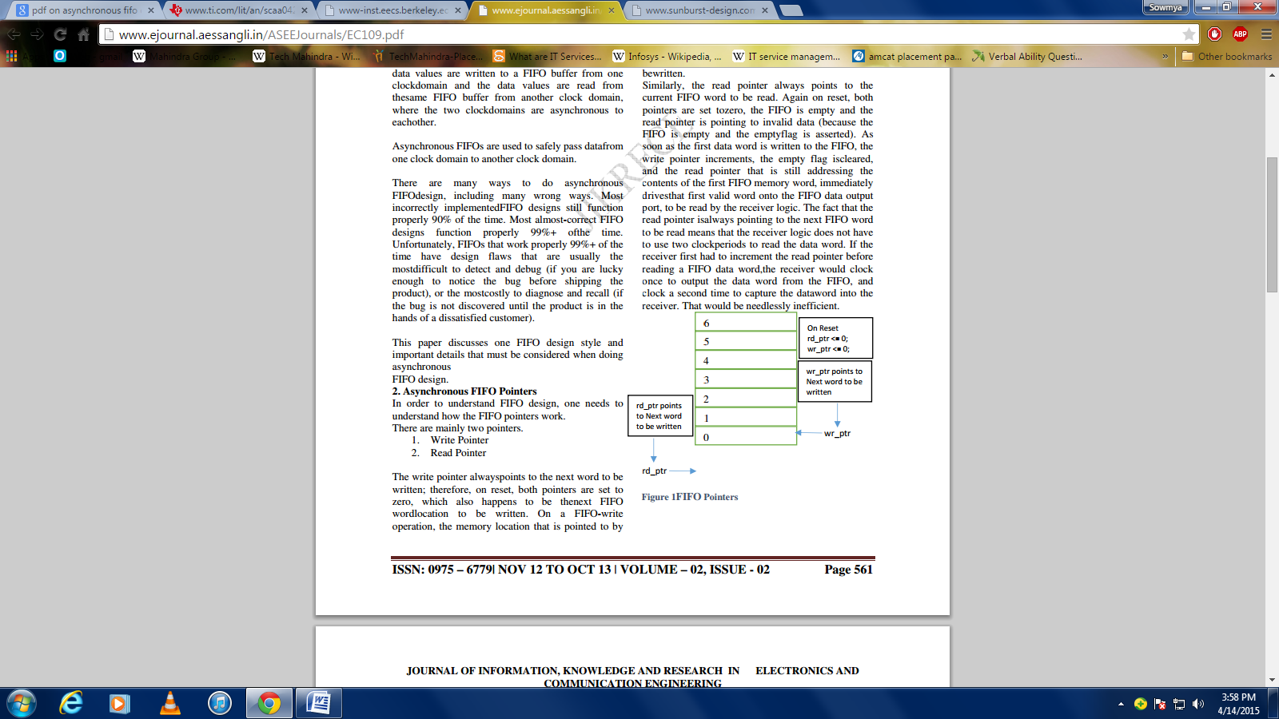

**Figure 5.21** FIFO Pointers

One design technique used to distinguish between full and empty is to add an extra bit to each pointer. When the write pointer increments past the final FIFO address, the write pointer will increment the unused MSB while setting the rest of the bits back to zero (the FIFO has wrapped and toggled the pointer MSB). The same is done with the read pointer. If the MSBs of the two pointers are different, it means that the write pointer has wrapped one more time that the read pointer. If the MSBs of the two pointers are the same, it means that both pointers have wrapped the same number of times.

Using n -bit pointers where (n-1) is the number of address bits required to access the entire FIFO memory buffer, the FIFO is empty when both pointers, including the MSBs are equal. And the FIFO is full when both pointers, except the MSBs are equal.

The FIFO design in this paper uses n-bit pointers for a FIFO with 2 (n-1) write-able locations to help handle full and empty conditions.

**5.5.1 Binary FIFO pointer considerations**

Trying to synchronize a binary count value from one clock domain to another is problematic because every bit of an n-bit counter can change. One approach to the problem is sample and hold periodic binary count values in a holding register and pass a synchronized ready signal to the new clock domain. When the ready signal is recognized, the receiving clock domain sends back a synchronized acknowledge signal to the sending clock domain. A sampled pointer must not change until an acknowledge signal is received from the receiving clock domain. A count-value with multiple changing bits can be safely transferred to a new clock domain using this technique. Upon receipt of an acknowledge signal, the sending clock domain has permission to clear the ready signal and re-sample the binary count value.

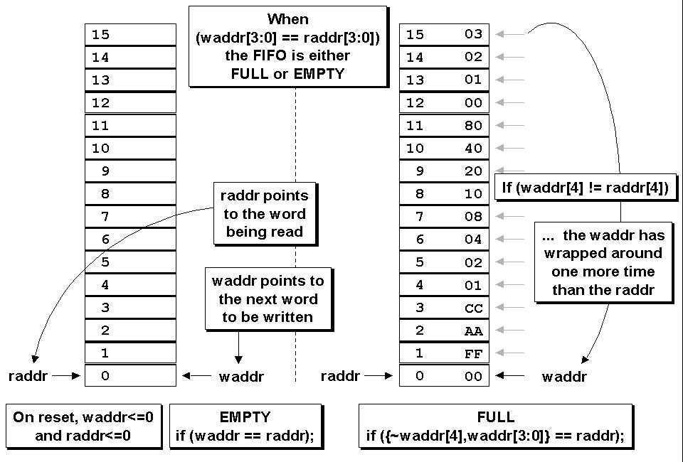

**Figure 5.22** FIFO full and empty conditions

Using this technique, the binary counter values are sampled periodically and not all of the binary counter values can be passed to a new clock domain The question is, do we need to be concerned about the case where a binary counter might continue to increment and overflow or underflow the FIFO between sampled counter values? The answer is no.

FIFO full occurs when the write pointer catches up to the synchronized and sampled read pointer. The synchronized and sampled read pointer might not reflect the current value of the actual read pointer but the write pointer will not try to count beyond the synchronized read pointer value. Overflow will not occur.

FIFO empty occurs when the read pointer catches up to the synchronized and sampled write pointer. The synchronized and sampled write pointer might not reflect the current value of the actual write pointer but the read pointer will not try to count beyond the synchronized write pointer value. Underflow will not occur. More observations about this technique of sampling binary pointers with a synchronized ready-acknowledge pair of handshaking signals are detailed in section 7.0, after the discussion of synchronized Gray code pointers.

A common approach to FIFO counter-pointers, is to use Gray code counters. Gray codes only allow one bit to change for each clock transition, eliminating the problem associated with trying to synchronize multiple changing signals on the same clock edge.

**5.5.2 Read pointer & Empty generation logic**

This module encloses all of the FIFO logic that is generated within the read clock domain (except synchronizers). The read pointer is an n-bit Gray code counter. The FIFO rempty output is asserted when the aempty_n signal goes low and the rempty output is de-asserted on the second rising rclk edge after aempty_n goes high (a rare metastable state could cause the rempty output to be de-asserted on the third rising rclk edge). This module is completely synchronous to the rclk for simplified static timing analysis, except for the aempty_n input, which is de-asserted asynchronously to the rclk.

**5.5.3 Write pointer & Full generation logic**

This module encloses all of the FIFO logic that is generated within the write clock domain (except synchronizers). The write pointer is an n-bit Gray code counter. The FIFO wfull output is asserted when the a full n signal goes low and the wfull output is de-asserted on the second rising wclk edge after afull_n goes high (a rare metastable state could cause the wfull output to be de-asserted on the third rising wclk edge). This module is completely synchronous to the wclk for simplified static timing analysis, except for the afull_n input, which is de-asserted asynchronously to the wclk.

**5.5.4 FIFO Testing Troubles**

Testing a FIFO design for subtle design problems is nearly impossible to do. The problem is rooted in the fact that FIFO pointers in an RTL simulation behave ideally, even though, if incorrectly implemented, they can cause catastrophic failures if used in a real design.

In an RTL simulation, if binary-count FIFO pointers are included in the design all of the FIFO pointer bits will change simultaneously; there is no chance to observe synchronization and comparison problems. In a gate-level simulation with no back annotated delays, there is only a slight chance of observing a problem if the gate transitions are different for rising and falling edge signals, and even then, one would have to get lucky and have the correct sequence of bits changing just prior to and just after a rising clock edge. For higher speed designs, the delay differences between rising and falling edge signals diminishes and the probability of detecting problems also diminishes. Finding actual FIFO design problems is greatest for gate-level designs with back annotated delays, but even doing this type of simulation, finding problems will be difficult to do and again the odds of observing the design problems decreases as signal propagation delays diminish.

Clearly the answer is to recognize that there are potential FIFO design problems and to do the design correctly from the start.

The behavioral model that sometimes use for testing a FIFO design is a FIFO model that is simple to code, is accurate for behavioral testing purposes and would be difficult to debug if it were used as an RTL synthesis model. This FIFO model is only recommended for use in a FIFO test bench. The model accurately determines when FIFO full and empty status bits should be set and can be used to determine the data values that should have been stored into a working FIFO.

**5.6 Synchronization Designs**

The use of write address and read address generating empty and full flag, the address must be passed to another clock in the region, but also to ensure that the address of the synchronization. During a number of addresses in the re-synchronization problems may occur, some other bits may be delayed a bit clock cycle, depending on the propagation characteristics of each respective lead. In other words, due to the asynchronous nature of the two clock regions are likely to sample some of the first rising edge of the clock is captured, the other may be the next rising clock is captured, depending on whether the data to the first flip-flop before the arrival of the clock edge, After sufficient setup time and hold time. We use technology to complete the double jump between the regions address the two asynchronous clock signal transmission, and its schematic diagram is shown below.



**Figure 5.23** Double jump technical principle diagram

**5.7 Advantages and Applications of Asynchronous FIFO**

**5.7.1 Advantages of asynchronous FIFO**

There must be a status flip-flop for each data word; therefore, the effort involved in controlling the data latches is justifiable only for very short FIFOs. With long FIFOs, there is also an enormous increase in fall-through time. For the 16 × 5 fall-through FIFO SN74S225, a maximum delay of 400 ns is specified from the READ CLOCK to the FULL signal. A 1024 × 18 FIFO, such as SN74ACT7881, requires a multiple of this time with fall-through architecture. The existence of fall-through architecture has a historical basis. New developments no longer use this principle.

**5.7.2 Applications of Asynchronous FIFO**

It is normally used in network components such as routers, switches, etc. and in electronic circuitry that we use on daily basis such as TVS, radios, MP3 players, etc. As to why not use an ordinary buffer is just not as efficient for today's and future applications.

**CHAPTER 6**

**RESULTS**

**6.1 Simulation Results**

**6.1.1 Asynchronous FIFO waveforms**

Data is written into the FIFO and read from it asynchronously. Below wave form shows that the FIFO is neither empty nor full.



**Figure 6.1** Asynchronous FIFO output

Data can be written into the FIFO when it is not full and write_en=1 at posedge i.e; w_clk else a full signal output is shown.



**Figure 6.2** Writing data into FIFO

Data can be read (r_data) only if the FIFO is not empty and read_en=1 at posedge r_clk; else an empty signal output is shown.



**Figure 6.3** Reading data from FIFO



**Figure 6.4** Write clock and enable, Read clock and enable

**6.2 Outputs from FPGA Board**

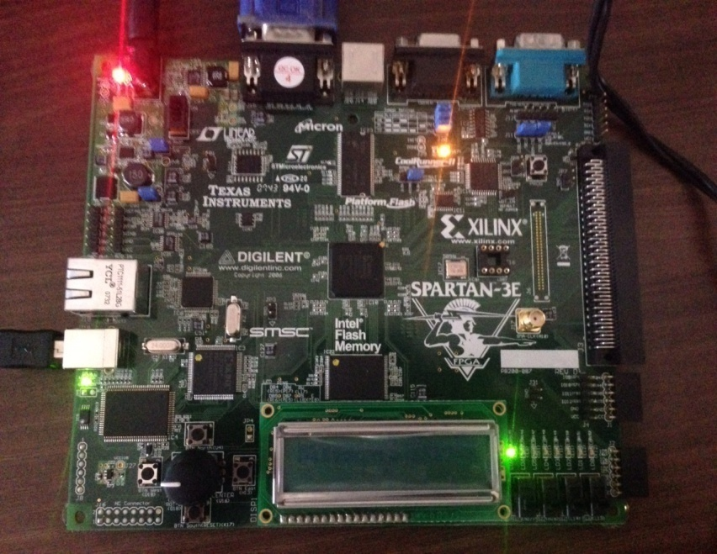

**Figure 6.5** Empty FIFO

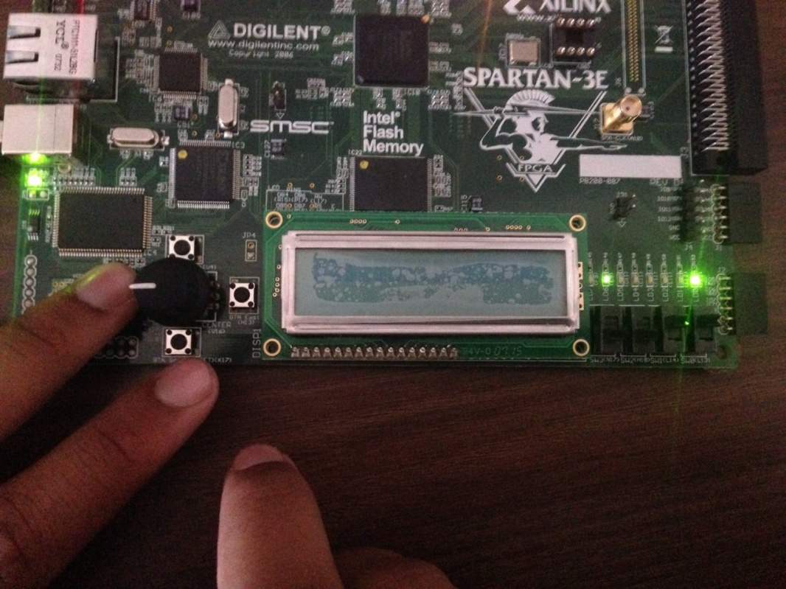

**Figure 6.6** 1 bit data written into the FIFO

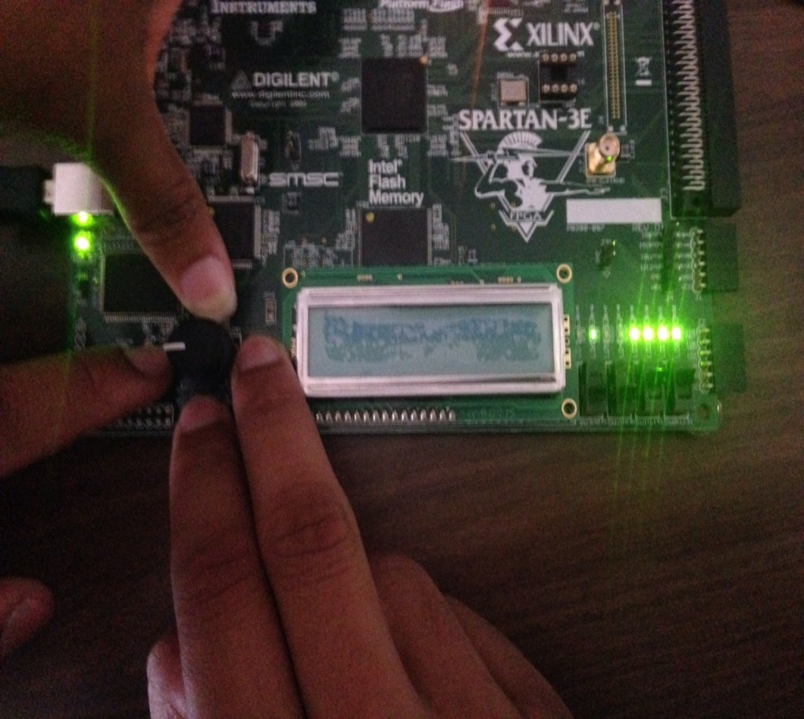

**Figure 6.7** 4 bit data is written and read from the FIFO

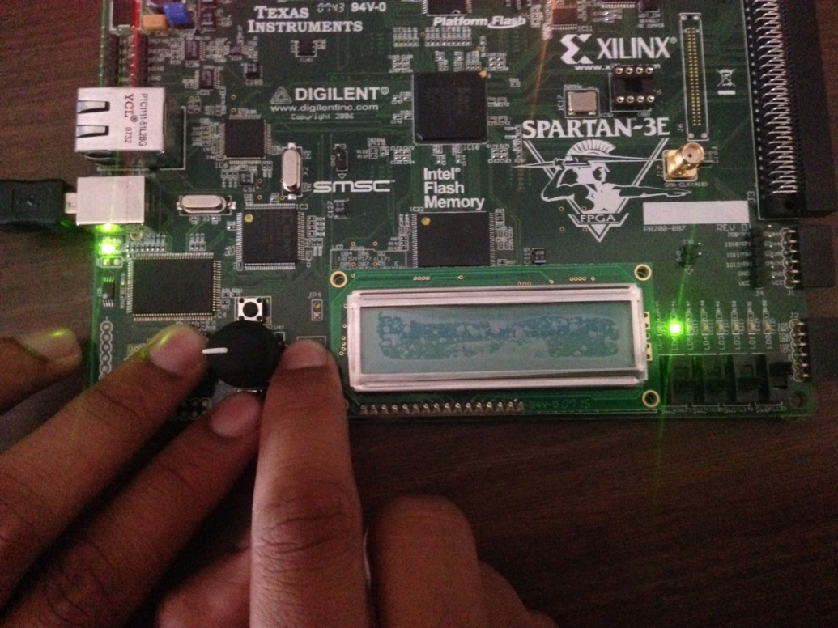

**Figure 6.8** Full FIFO

**CHAPTER 7**

**CONCLUSIONS**

Asynchronous FIFO design requires careful attention to details from pointer generation techniques to full and empty generation. Ignorance of important details will generally result in a design that is easily verified but is also wrong. Finding FIFO design errors typically requires simulation of a gate-level FIFO design with back annotation of actual delays.

Synchronization of FIFO pointers into the opposite clock domain is safely accomplished using Gray code pointers. Generating the FIFO-full status is perhaps the hardest part of a FIFO design. Dual n-bit Gray code counters are valuable to synchronize and n-bit pointer into the opposite clock domain and to use an (n-1)-bit pointer to do “full” comparison. Synchronizing binary FIFO pointers using techniques is another worthy technique to use when doing FIFO design.

Generating the FIFO-empty status is easily accomplished by comparing-equal the n-bit read pointer to the synchronized n-bit write pointer.

Careful partitioning of the FIFO modules along clock boundaries with all outputs registered can facilitate synthesis and static timing analysis within the two asynchronous clock domains.

**REFERENCES**

1. Van de Goor, AI, Schanstra I. Zorian Y, Fault Models and Tests for Ring Address.
2. Nobutaro Shibata.maynmi watanabe. A current-sensed high speed and low-power first in first out memory using a wordline/bitli
3. ne-swapped dual-port sram cell. IEEE Journal of Solid State Circuites. VOL_37, NO. 6, JUNE 2002.
4. Application note virtex series, xapp13I (v1.7) march 26.2003.www.xilinx.com.
5. Maritti Juhola.Comparison of Algorithms for Standard Median Filtering IEEE-TRANS ASSP-39 1991.
6. [Clifford E. Cummings, “Synthesis and Scripting Techniques for Designing Multi-Asynchronous Clock Designs,” SNUG 2001 (Synopsys Users Group Conference, SanJose, CA, 2001) User Papers, March 2001, Section MC1, 3rd paper.
7. Clifford E. Cummings and Peter Alfke, “Simulation and Synthesis Techniques for Asynchronous FIFO Design with Asynchronous Pointer Comparisons,” SNUG 2002 (Synopsys Users Group Conference, San Jose, CA, 2002) User Papers, March 2002, Section TB2, 3rd paper. Also available at www.sunburst-design.com/papers.